## Table of Content

CHAPTER 1 INTRODUCTION 1

* 1. Purpose of project 1
  2. How it works 1
  3. Project Scope 2
  4. Project Planning 2
     1. Requirements 3
     2. Design 3
     3. Implementation 3
     4. Verification 3
     5. Release 3
  5. Project modules 3
     1. User Interface (Home) 3
     2. About us 4
     3. Contact 4
     4. Backend 4

CHAPTER 2 BACKGROUND & PROBLEM DEFINITION 5

* 1. Background Research 5
  2. Existing Technology 5
  3. Area of study 7
  4. Reason of the Project 7
     1. Accuracy of Information 8
     2. Efficiency 8
     3. Easy to Use 9
     4. Security 9
     5. User Friendly 10
     6. Time Saving 10
  5. Objectives of the Project 10
  6. Methodology 10

CHAPTER 3 SYSTEM REQUIREMENT ANAYLSIS 11

* 1. System Functional Requirements 11
     1. Project Interactivity Plan 11
     2. Signup Information 11
     3. Login Information 11
     4. Tour Record 11
        1. Add Tour 11
        2. Update Record 12
        3. Delete Record 12
     5. Booking Record 12
        1. Add Booking 12
        2. Update Record 13
        3. Delete Record 13
     6. Payment Method 13
     7. SRS Document (System Requirements Specification) 14
  2. Non-Functional Requirements of the system 14
  3. Hardware & Software Requirements 15
     1. Software Requirements 15
     2. Hardware Requirements 15
     3. Tools & Technologies 15
     4. Introduction of Tools 16
        1. Sublime 16
        2. HTML 16
        3. CSS (Cascade Style Sheet) 17
        4. Bootstrap 17
        5. JavaScript 18
        6. JQuery 18
        7. PHP 19
        8. Ajax 19
        9. MySQLi 20

CHAPTER 4 SYSTEM DESIGN 21

* 1. Use case – fully dressed 21
     1. Importance of Use Case Diagrams 21
     2. Use Case Diagram objects 21
        1. Actor 22
        2. Use case 22
        3. System 22
        4. Package 23
     3. Use Case Diagram of User Login 23
     4. Use case of Tour Planner 24
  2. WBS fully dressed 25
  3. System Sequence diagram 26
  4. Class diagram 27
  5. ER Model 28
  6. Data Flow Diagram 29
     1. Symbols and Notations Used in DFDs 29
     2. Data Flow Diagram of Tour Planner 29

CHAPTER 5 IMPLEMEMNTATION & TESTING 32

* 1. Testing Methods 32
  2. Functional vs non-functional testing 32
     1. Functional Testing 33
     2. Non- functional Testing 35
  3. Test Cases 39
     1. Data and Database Integrity Testing 39
     2. Function testing 40
     3. User interface Testing 41
     4. Performance Testing 42
     5. Security and access control testing 43

CHAPTER 6 USER MANUAL 44

* 1. Main/Home view 44
  2. About Agency 46
  3. Contact page 48
  4. Tour detail page 50
  5. Signup/Login page 50
  6. Tour booking form 51
  7. Payment Method 51
  8. Successfully Booked 52
  9. User Dashboard 52
  10. Admin Dashboard 53
  11. Testimonial 53
  12. Manage Tour 54
  13. Manage Bookings 54
  14. Read Messages 55
  15. Coding 55
      1. Database Connection File 55
      2. Admin Panel code 56
      3. Frontend Code 56
  16. Database 57
  17. Tour Record 57
  18. Booking Record 58
  19. Contact detail 58
  20. Payment detail 59
  21. Slider detail 59
  22. Testimonial detail 60
  23. Places detail 60

**List of Figures**

***Figure 2.1*:** Accuracy 8

***Figure 2.2*:** Efficiency 9

***Figure 2.3*:** Security 9

***Figure 3.1*:** Sublime 16

***Figure 3.2:*** HTML 17

***Figure 3.3*:** Cascade Style Sheet 17

***Figure 3.4*:** Bootstrap 18

***Figure 3.5*:** JavaScript 18

***Figure 3.6*:** JQuery 19

***Figure 3.7:*** PHP 19

***Figure 3.8*:** Ajax 20

***Figure 3.9*:** MySQLi 20

***Figure 4.1*:** Actor 22

***Figure 4.2*:** Use case 22

***Figure 4.3:*** System 22

***Figure 4.4*:** Package 23

***Figure 4.5*:** User login 23

***Figure 4.6*:** Use case of tour planner 24

***Figure 4.7*:** WBS Fully Dressed 25

***Figure 4.8*:** Sequence Diagram 26

***Figure 4.9*:** Class diagram 27

***Figure 4.10*:** ER Diagram 28

***Figure 4.11*:** Data Flow Diagram 29

***Figure 4.12*:** Context level DFD 29

***Figure 4.13*:** Admin level 1 DFD 30

***Figure 4.14*:** User level 31

***Figure 4.15*:** Tourist Places 31

***Figure 5.1*:** Unit Testing 33

***Figure 5.2*:** Integration Testing 34

***Figure 5.3*** System Testing 34

***Figure 5.4*:** Acceptance Testing 35

***Figure 5.5*:** Load Testing 36

***Figure 5.6*:** Stress Testing 37

***Figure 5.7*:** Compatibility Testing 38

***Figure 6.1*:** Home Screen 44

***Figure 6.2*:** Home Page Tours Detail 44

***Figure 6.3*:** Home page Services 45

***Figure 6.4:*** Testimonial 45

***Figure 6.5*:** About page 46

***Figure 6.6*:** About Agency 46

***Figure 6.7*:** Team 47

***Figure 6.8*:** Agency Timeline 47

***Figure 6.9*:** Destinations 48

***Figure 6.10*:** Contact Us 48

***Figure 6.11*:** Contact Form 49

***Figure 6.12*:** Footer 49

***Figure 6.13*:** Tour detail 50

***Figure 6.14*:** Signup and login form 50

***Figure 6.15*:** Booking form 51

***Figure 6.16*:** Payment method 51

***Figure 6.17*:** Booked Successfully 52

***Figure 6.18*:** User dashboard 52

***Figure 6.19*:** Admin Dashboard 53

***Figure 6.20*:** Testimonial 53

***Figure 6.21*:** Manage Tour 54

***Figure 6.22*:** Manage Booking 54

***Figure 6.23*:** Read Messages 55

***Figure 6.24*:** Connection 55

***Figure 6.25*:** Admin Panel 56

***Figure 6.26*:** Frontend 56

***Figure 6.27*:** Database 57

***Figure 6.28*:** Tour Record 57

***Figure 6.29:*** Booking record 58

***Figure 6.30*:** Contact detail 58

***Figure 6.31*:** Payment detail 59

***Figure 6.32*:** Slider detail 59

***Figure 6.33*:** Testimonial details 60

***Figure 6.34*:** Places detail 60

## Table of Figures

***Table 3.1:*** Software Requirement Specification 14

***Table 5.1:*** Data Integrity Testing 39

***Table 5.2:*** Function Testing 40

***Table 5.3:*** User Interface Testing 41

***Table 5.4:*** Performance Testing 42

***Table 5.5:*** Security and access testing 43

# CHAPTER 1 INTRODUCTION

### Purpose of project

The main purpose of the Web App is to facilitate the offline customer online because customers cannot spend their precious time in markets trying to find out the best deal.

Remember those times when you had to scour newspapers and magazines to find out about tour booking. When you had to hail a taxi by hand and rely on paper maps to explore a new place. When every single information and tour had to be booked by physically visiting the buildings. That time was not a long time ago. Technology has changed the tourism industry at an exponential rate in the last two decades.

My main motive is to promote tourism in Pakistan. The purpose of this project is provide the complete information about tour in single click. Our priority will be our customers and their travel requirements

The problem is that we although having many Web Apps but they offer different kind of services and the customer are enjoying a lot but there is a lack of relationship between travel agency and customers and hence we are establishing that relationship by caring and serving all customers in the same manner that we wish to be served.

There will be many users visiting the web app and hence we require a strong and reliable frontend which can withhold the users on our site and team armed with knowledge and backed by technology to advise customers in planning of their holidays and to answer their queries. I will be putting an effort to provide the right choice the people when they plan a holiday and beware them from the false advertising.

### How it works

This web app has five major modules built together with attractive user interface. Our app module name Booking Module, Admin Panel, Customer Panel, Payment Method and Guest Users. Each module performs different functionality as we clicked on Icon.

First of all user signup an account otherwise login and then search tour according to their taste and when customer select a tour then it move on next page in which they get

information regarding tour. After that customer move on booking page and completing booking form customer move on payment method. After doing all these task customer booked their tour successfully.

### Project Scope

Smartphones, tablets, and mobile devices have become ubiquitous. An interactive travel web app in these gadgets is a handy tool. The users can search for maps, tourist spots, special offers and ticket prices. No wonder MOBILE APP DEVELOPMENT SERVICES are focusing more on the tourism sector nowadays. The best web apps make it easy to plan and go on adventurous vacations. You can also check regional weather forecasts and start on a road trip. Actually, my web app has following major features listed below.

* + - User friendly Interface.
    - Providing secure login facility.
    - Save from unauthorized access.
    - View the detail of tour.
    - Booking detail.
    - Payment Method.

### Project Planning

Main purpose of this project is to facilitate the tourist to manage their tour online. It will save the time of users. Similar requirement can be easily available. The software looks for new data automatically, fetching the new updates and storing them for user easiness.

This project is supported by Rimsha Shoukat and the Supervisor Ms. Qoseen Zahra and our IT staff Members have supported me in fulfilling the task of this project. They motivated me to do this project. I met our Supervisor weekly. Supervisor helped me to develop this project more efficient. Then I started to develop this project. The goal of this section is to provide a set of recommendations that will help you plan appropriately for a successful project. The best web apps make it easy to plan and go on adventurous vacations. You can also check regional weather forecasts and start on a road trip. In this section, I use the life cycle model employed broadly at Microsoft. This model is a combination of

iterative and waterfall life cycle models. In this model, there are five phases whose boundaries define a sequential set of milestones for the project. The phases, in order of execution, are as follows:

#### Requirements

To make ensure data handling process and user friendly monitoring system which send the notification to authorized person which is responsible to response the author for send and correct data to the user according to their requirements.

#### Design

Based on the functional requirements, physical design specifications are created and prototyping is conducted to verify design ideas and investigate the capabilities.

#### Implementation

Using the design and functional specifications, the coding is done. And all the code is working well. It gives same output as we want for user or admin

#### Verification

This is the process of testing the product to verify that is performs according to the specifications. All the verification is done using different methods and it shows everything perfect.

#### Release

After the product has been fully verified it is prepared for release to Customers. And then user can easily export that prepared file for future use.

### Project modules

#### User Interface (Home)

* + - * Home page with the option of login.
        + User Can Register his/herself
        + User login with valid email and password
      * Our Best Tours
      * Our Services
      * Testimonial

#### About us

* + - * Our Team
      * Destinations

#### Contact

* + - * Address
      * Phone
      * Email
      * Opening Hours
      * Contact Form

#### Backend

* Admin Panel
* Client Panel
* Admin create packages
* Manage Package (Update, Delete)
* Manage Places/Destination
* Manage Recommended Tours
* Send Notifications
* Manage Expense
* Manage Customers
* Testing & Bug Fixing
* Manage booking confirmation and cancellation of tour
* Manage Customer’s detail
* Give response to customer’s query
* View
* Booked
* Update
* Check Status
  + Send messages (Before One day earlier)

# CHAPTER 2 BACKGROUND & PROBLEM DEFINITION

### Background Research

Remember those times when you had to scour newspapers and magazines to find out about tour booking. When you had to hail a taxi by hand and rely on paper maps to explore a new place. When every single information and tour had to be booked by physically visiting the buildings. That time was not a long time ago. Now a day the life style of the people is different. People feel uncomfortable and time consuming for going to office for booking. So, online booking saves lot of time. Online booking are usually available 24 hours a day have internet access at all. So it is very convenient for them to book tour online. Technology has changed the tourism industry at an exponential rate in the last two decades.

An increasing amount of research has been conducted to understand the impacts of tourism development from the resident’s perspective. The driving force behind these phenomena can be attributed to the fact that the tourism business has fueled the economic growth of both the community and the nation, and has additionally played a vital role in social, cultural, and environmental impacts on people, destinations and countries.

The main purpose of the Web App is to facilitate the offline customer online because customer cannot spend their precious time in markets trying to find out the best deal.

### Existing Technology

Not so long ago, computer revolutionized the travel industry. The evaluation of the internet, the smartphone and other technologies now provide significant convenience and savings to travel consumers. Travel website that allow travelers to find best deals, self-guided, tour booking, arrival and departure are now standard travel tools, accessible to both travel professionals and consumers alike.

#### Travel websites

There is a plethora of online travel sites, which can be used for many different purpose:

#### Research

Individual vendor websites, third-party booking sites provide information, reviews and price comparisons for travel products. Travelers who prefer to not work with a travel agent can easily complete necessary research and select the vendors with the best prices.

#### Booking

Both travel agent and consumers alike can book travel online, without ever having to speak to a vendor representative.

#### Travel updates

Travelers can now check in regarding their booking via a website. In addition, family and friends can also use online systems to track the arrival of their guests. Travelers can now check in regarding their booking via a website.

#### Loyalty points

Website allow loyalty point program members to check their status and redeem points as they wish. Some travel agents use web app to make themselves available to travelers who may need to reschedule a missed booking.

#### Smart Communication apps

When things go wrong while travelling, it’s essential to be able to communicate with people who can help, such as customer service representative and travel agents. Some travel agents use web app to make themselves available to travelers who may need to reschedule a missed booking.

#### What tomorrow may bring

Technology moves ahead by leaps and bounds. The travel is already witnessing inroads in several new areas, including:

#### Customer recognition

Camera-based technology can recognize a customer’s face as they enter your hotel, or a Bluetooth systems can pick up a signal from a familiar cell phone, letting management know a repeat visitor is in the house.

#### Virtual Reality

Travelers like to be entertained, and in-room may not be enough. Virtual reality might be the next wave of entertained and can also find use in introducing visitors to the delights that an area offers, even well before they arrive.

### Area of study

Technology nowadays plays a significant role in our lives. From simple machines to complex ones technology is used. This system is used by many companies or cities to facilitate the customer for online booking.

Tourism is one of the areas that can provide source of income in the community. For the purpose of promoting the tourism, the website must be accessible everywhere. A tourism destination website usually is a Business to Customer (B2C site), whose main target are the tourists. Websites can support all the core activities of a Tourism Destination. Like Tour detail, booking and payment method.

### Reason of the Project

A travel website is a website that is dedicated to travel. The site may be focused on travel reviews, trip fares, or a combination of both. Over 1.5 billion people book travel per year, 70% of which is done online. My main motive is to promote tourism in Pakistan. The purpose of this project is provide the complete information about tour in single click. Our priority will be our customers and their travel requirements. Tour industry contribute 7.4% GDP which is not enough. Current government decide to generate 1 Trillion revenue from the tour industry at the end 2025. If the tour industry emerge then the problem of unemployment resolved too. In Pakistan 300% tourism grow from 2017-2020. Some main function of this system:

#### Accuracy of Information

The accuracy of information or measurements is their quality of being true or correct, even in small details. The information of data organization in information system can affect the speed, cost and of desired processing activities. Since all the calculation is done automatically, so the chances of error are very rare, which results in accuracy of system. The developed system provides powerful searching mechanism. This can even search a minor record in less than a second because the stored data in database is in accurate form due to validation checks. A computerized system’s accuracy is 100% while in manual it is on 40%.



***Figure 2.1:*** Accuracy

#### Efficiency

The developed system is greater efficient than the older one. Wrong data entry is impossible as there are different checks that do not allowed to enter wrong data because of validations. The classification efficiency of the single-cycled classification model is intuitively worse than the multi-cycled model, as it requires more effort in collecting relatively comprehensive software measurement data to classify each unseen case. It is extremely important that software project managers determine which type of classification model is best suited to their specific objectives, since such a choice will significantly affect the accuracy and efficiency of the classification results.



***Figure 2.2:*** Efficiency

#### Easy to Use

The source data input, review and modification can be repeated any number of times on computer graphics. The power system graphics generation should be easy and efficient. The web app is very easy to use and operate.

#### Security

Application security means many different things to many different people. Security should be explicitly at the requirement level. Security methods are under the high level class and are considered to be an addition in to the original software. The habits formed from initial programming can be for a long time. Security is considered as a very critical issue for software systems. Software is itself a resource and thus must be afforded appropriate security. Software that is developed with security in mind is typically more resistant to both intentional attack and unintentional failures.



***Figure 2.3:*** Security

#### User Friendly

Term user friendly refers to anything that makes it easier for novices to use a computer. Menu-driven programs, for example, are considered more user-friendly than command- driven systems. Online help systems are another feature of user-friendly programs.

#### Time Saving

Due to high speed of processing, the proposed system takes less time to access information from database and as it is online system so it is definitely time saving then going physically to office for tour booking.

### Objectives of the Project

This study generally aims to promote the tourism by developing web application for Tour Guide. This study specifically aims to:

* The purpose of this project is provide the complete information about the tour in single click. Our priority will be our customers and their travel requirements.
* Make it accessible anywhere for customer as long as it connected to the internet.
* It will be putting an effort to provide the right choice the people when they plan a holiday and beware them from the false advertising.

### Methodology

The project consisted of the following components:

* This system provide the facility to customer to book a tour according to his/her choice.
* This system is also provide the facility of viewing tour detail.
* User may book tour after select a city.
* After booking customer move on payment method.
* Then receive tour conformation alert.
* Admin can approve and disapprove requested tour.
* Admin can also control full website through admin panel like add tours, places, slider images and testimonial.
* Admin can also give response on the queries of customer.

# CHAPTER 3 SYSTEM REQUIREMENT ANAYLSIS

### System Functional Requirements

The requirement of system must be fulfilled for proper working of the system. Such requirements describe system behavior under specific conditions and include the product features and functions which web & app developers must add to the solution. Such requirements should be precise both for the development team and stakeholders.

#### Project Interactivity Plan

Website is user friendly due to third party control. User can save record and system is easy to use by user through user friendly GUI’s.

#### Signup Information

User must provide information in the form of First name, Last name, Email, Password and Confirm password then click on signup button to register his/herself.

#### Login Information

User must provide username and password to login into the system. If admin want to delete the user he/she can do it by clicking delete button in the user list visible.

#### Tour Record

Admin can add, delete and update tours through admin panel.

#### Add Tour

Admin can added tour by entering complete description data from keyboard into fields and clicking on add button. The following fields are required:

* + - * + Tour Name
        + Departure Date
        + Arrival Date
        + City
        + Season
        + Description
        + Food plan
        + Conveyance
        + Price
        + Picture
        + Then click on submit button

#### Update Record

If the Admin is going to update the Tour following fields required:

* + - * + Tour Name
        + Departure Date
        + Arrival Date
        + City
        + Season
        + Description
        + Food plan
        + Conveyance
        + Price
        + Picture
        + Then click on update button

#### Delete Record

If Admin wants to delete the user record he/she can do it by clicking delete button.

* + - * + User ID

#### Booking Record

Admin can view booking detail. Admin can also confirm and cancel the tour just on one click.

#### Add Booking

If the user want to booked a tour after the selection of city. The following fields are required:

* + - * + Name
        + Last name
        + Email
        + Mobile
        + Pickup location
        + Pickup date
        + Pickup Time
        + No. of Adults
        + No. of children

#### Update Record

If the User is going to update the booking detail following fields required:

* + - * + Name
        + Last name
        + Email
        + Mobile
        + Pickup location
        + Pickup date
        + Pickup Time
        + No. of Adults
        + No. of children

#### Delete Record

If User wants to delete the user record he/she can do it by clicking delete button.

* + - * + User ID

#### Payment Method

For payment method user add following detail:

* Owner Name
* Credit card#
* Expire year
* Expire Month
* Card code

#### SRS Document (System Requirements Specification)

***Table 3.1:*** Software Requirement Specification

|  |  |
| --- | --- |
| **Sr. No.** | **Description** |
| SRS-01 | System should be able to provide login facility |
| SRS-02 | System should be able to provide Sign Up facility |
| SRS-03 | System should be able to Add New Tour |
| SRS-04 | System should be able to Update Tour |
| SRS-05 | System should be able to Delete Tour |
| SRS-06 | System should be able to Book a tour |
| SRS-07 | System should be able to Update booked tour |
| SRS-08 | System should be able to Delete booked tour |
| SRS-09 | System should be able to do payment method smoothly |

### Non-Functional Requirements of the system

* The non-functional requirements elaborate a performance characteristic of a system.
* Non-functional requirements specify the quality of a system, is mostly related the satisfiability of the user.
* Ensure the privacy of customers.
* Exclude unauthorized access.
* Reliability
* Flexibility
* User Safety
* User Friendly
* Satisfiability of the user

### Hardware & Software Requirements

#### Software Requirements

* Operating system: window 7/8/8.1/10
* Database: MySQLi
* Web Browser: Google Chrome
* Web page style sheet: HTML, CSS, Bootstrap, JavaScript, Ajax and JQuery
* Program code: PHP, MySQLi

#### Hardware Requirements

* Availability of Internet
* Minimum 4GB Main Memory
* CPU speed: 2.6GHz
* Monitor: EGA/SVGA (display),800X600 24 bits true color
* Standard keyboard
* Mouse
* CD-ROM Required

#### Tools & Technologies

Coding is a process of turning program logic into specific instructions that can be executed by the computer system. In developing the project, selection of tool is the main and important factor to be considered during the development of a new system, as proposed system performance based on the tools used for its development. Behind a successful project, there lie a lot of factors and efforts. The selection of tool is really a big factor in the success of any project. The decision depends on many factors, which includes the nature of the problem, nature and amount of data, need of users or customers, and the available facilities. After the detailed studies and comparison of some common tools, analyzing the problems of old system, considering the organization needs and keeping in view all the related things this project was developed using the tools:

* Sublime
* HTML
* CSS
* JavaScript
* JQuery
* Ajax
* PHP
* MySQLi
* XAMPP

#### Introduction of Tools

#### Sublime

Sublime Text is a shareware cross-platform source code editor with a Python application programming interface (API). It natively supports many programming languages and markup languages, and functions can be added by users with plugins, typically community- built and maintained under free-software licenses. Sublime Text may be downloaded and evaluated for free, however a license must be purchased for continued use. There is no enforced time limit for the evaluation. It'll prompt you to purchase every 'X' no. of times you've saved a file.



***Figure 3.1:*** Sublime

#### HTML

HTML is short for Hyper-Text Markup Language and is a language used to create electronic documents, especially pages on the World Wide Web that contains connections called hyperlinks to other pages.

HTML (Hypertext Markup Language) is the code that is used to structure a web page and its content. For example, content could be structured within a set of paragraphs, a list of bulleted points, or using images and data tables.



***Figure 3.2:*** HTML

#### CSS (Cascade Style Sheet)

CSS stands for Cascading Style Sheets. It describes how HTML elements are to be displayed on screen, paper, or in other media. CSS saves a lot of work. It can control the layout of multiple web pages all at once. External stylesheets are stored in CSS files. CSS is the language for describing the presentation of Web pages, including colors, layout, fonts and it allows one to adapt the presentation to different types of devices, such as large screens, small screens, or printers. CSS is independent of HTML and can be used with any XML-based markup language.



***Figure 3.3:*** Cascade Style Sheet

#### Bootstrap

Bootstrap, which is the most popular HTML, CSS, and JavaScript framework for developing responsive and mobile-first website. Bootstrap is a free collection of tools for creating websites and web applications. It contains HTML and CSS-based design templates for typography, forms, buttons, navigation and other interface components, as well as optional JavaScript extensions. Bootstrap is a framework to help you design websites faster and easier. It includes HTML and CSS based design templates for typography, forms,

buttons, tables, navigation, modals, image carousels, etc. Here are some additional reasons to use Bootstrap: Bootstrap's responsive CSS adjusts to phones, tablets, and desktops.



***Figure 3.4:*** Bootstrap

#### JavaScript

JavaScript is a text-based programming language used both on the client-side and server- side that allows you to make web pages interactive. Where HTML and CSS are languages that give structure and style to web pages, JavaScript gives web pages interactive elements that engage a user. JavaScript can calculate, manipulate and validate data.

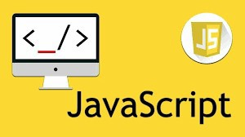

***Figure 3.5:*** JavaScript

#### JQuery

JQuery is a JavaScript Library. It greatly simplifies JavaScript programming. JQuery is a fast, small, and feature-rich JavaScript library. It makes things like HTML document traversal and manipulation, event handling, animation, and Ajax much simpler with an easy-to-use API that works across a multitude of browsers. (jquery.com).The purpose of jQuery is to make it much easier to use JavaScript on your website. JQuery takes a lot of

common tasks that require many lines of JavaScript code to accomplish, and wraps them into methods that you can call with a single line of code.



***Figure 3.6:*** JQuery

#### PHP

PHP is a server scripting language, and a powerful tool for making dynamic and interactive Web pages. PHP is a widely-used, free, and efficient alternative to competitors such as Microsoft's ASP. PHP is a server-side scripting language that is used to develop Static websites or Dynamic websites or Web applications. PHP stands for Hypertext Pre- processor, that earlier stood for Personal Home Pages. PHP scripts can only be interpreted on a server that has PHP installed.



***Figure 3.7:*** PHP

#### Ajax

Update a web page without reloading the page. Ajax Request data from a server - after the page has loaded. It Receive data from a server - after the page has loaded. It Send data to a server - in the background.



***Figure 3.8:*** Ajax

#### MySQLi

* + - * + MySQLi is a freely available open-source Relational Database Management System (RDBMS) that uses Structured Query Language (SQL). SQL is the most popular language for adding, accessing and managing content in a database. It is most noted for its quick processing, proven reliability, ease and flexibility of use

1.15.10 Server-Side Programming: PHP will be used as server side programming. The 'i' in **MySQLi** stands for Improved. Therefore, this is also known as the improved version of MySQL.

* + - * + MySQLi is an open-source relational database management system (RDBMS) in July 2013, it was the world's second most widely used RDBMS, and the most widely used open-source client–server RDBMS.
        + Basically, MySQL is the old database driver, and MySQLi is the improved driver. MySQLi can be done procedural and object-oriented whereas MySQL can only be used procedurally. MySQLi, also supports prepared statements which protect from SQL Injection.



***Figure 3.9:*** MySQLi

# CHAPTER 4 SYSTEM DESIGN

### Use case – fully dressed

A use case is a description of a system’s behavior from a user’s standpoint. For system developers, this is a valuable tool: requirements from a user’s point of view. Use case diagrams are used to gather the requirements of a system including internal and external influences. These requirements are mostly design requirements. Hence, when a system is analyzed to gather its functionalities, use cases are prepared and actors are identified.

#### Importance of Use Case Diagrams

As mentioned before use case diagrams are used to gather a usage requirement of a system. Depending on your requirement you can use that data in different ways. Below are few ways to use them.

* + - * **To identify functions and how roles interact with them** – The primary purpose of use case diagrams.
      * **For a high-level view of the system** – Especially useful when presenting to managers or stakeholders. You can highlight the roles that interact with the system and the functionality provided by the system without going deep into inner workings of the system.
      * **To identify internal and external factors** – This might sound simple but in large complex projects a system can be identified as an external role in another use case.

#### Use Case Diagram objects

Use case diagrams consist of 4 objects.

* + - * Actor
      * Use case
      * System
      * Package

#### Actor

Actor in a UML Use Case Diagram is any entity (person, organization or external system) that performs a role in one given system. In a use case diagram, an actor interacts with a use case.

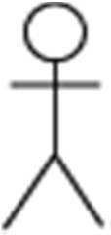

***Figure 4.1:*** Actor

#### Use case

A use case in a UML Use Case Diagram gives a visual representation of distinct business functionalities in a system.

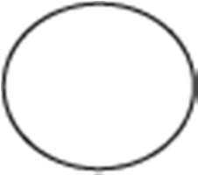

***Figure 4.2:*** Use case

#### System

A system in a UML Use Case Diagram is a rectangle spanning all the use cases in the system that defines the scope of your system. Anything within the box represents functionality that is in scope and anything outside is not. Note that the actors in the system are outside the system.



***Figure 4.3:*** System

#### Package

A package object in a UML Class and Use Case Diagram provides the ability to group together classes and/or interfaces that are either similar in nature or related. Grouping these design elements in a package element provides for better readability of UML diagrams, especially complex diagrams.

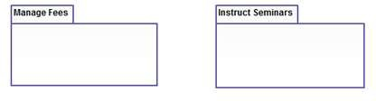

***Figure 4.4:*** Package

#### Use Case Diagram of User Login

In the rare case you are performing the use case analysis of some authentication or user management software, such as an SSO solution, in which the business value for the user is really to get logged into some protected systems, login is a use case.

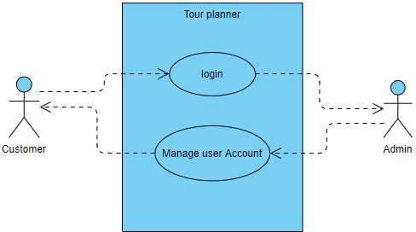

***Figure 4.5:*** User login

#### Use case of Tour Planner

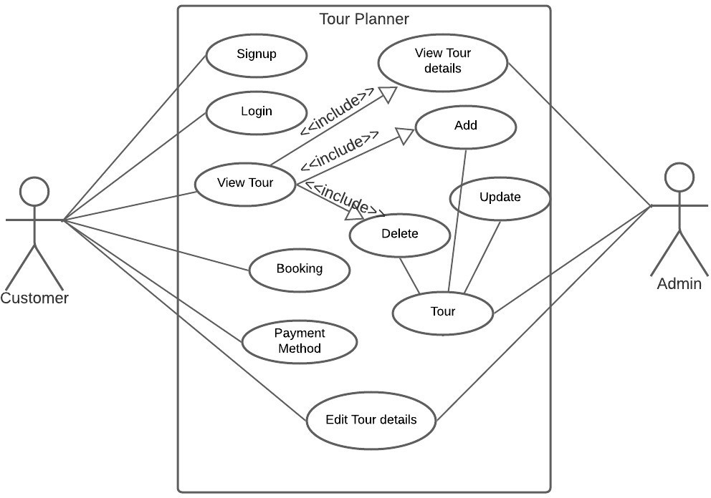

***Figure 4.6:*** Use case of tour planner

#### Pre-Conditions

* + - * + User must be logged in.

#### Flow of events

* + - * **Primary Scenario**
* User will open the Tour Info Form from the main Menu.
* User will click on the record on data grid view and it will load on text boxes.
* The information about the specific tour is loaded.
* User modifies the selected tour and information after login.
* User can book tour.
* User can edit tour detail.
* After Booking user can add payment method.

#### Secondary Scenario

* User can cancel the operation any time.

#### Post Condition

* The record of the Tour is added successfully.

### WBS fully dressed

* + - Work breakdown structure allows you to decompose project into small manageable sections, also known as deliverables. Clearly defined deliverables are easy to assign, allow you to accurately estimate needed time and resources and track their completion.
    - Work breakdown structure (WBS) in project management is a method for completing a complex, multi-step **project**. It's a way to divide and conquer large projects to get things done faster and more efficiently. The goal of a WBS is to make a large project more manageable.

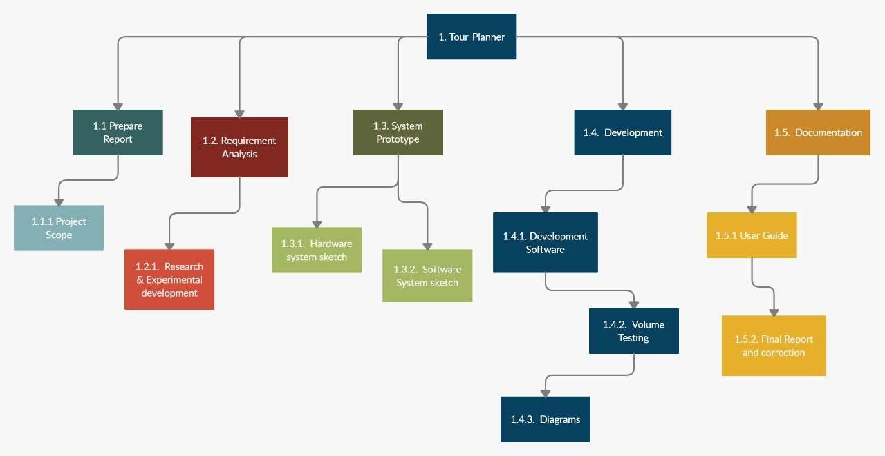

***Figure 4.7:*** WBS Fully Dressed

### System Sequence diagram

* + - Sequence Diagrams are interaction diagrams that detail how operations are carried out. They capture the interaction between objects in the context of a collaboration.
    - Sequence Diagrams are time focus and they show the order of the interaction visually by using the vertical axis of the diagram to represent time what messages are sent and when.
    - A sequence diagram simply depicts interaction between objects in a sequential order i.e. the order in which these interactions take place. We can also use the terms event diagrams or event scenarios to refer to a sequence diagram.
    - Sequence diagrams describe how and in what order the objects in a system function.

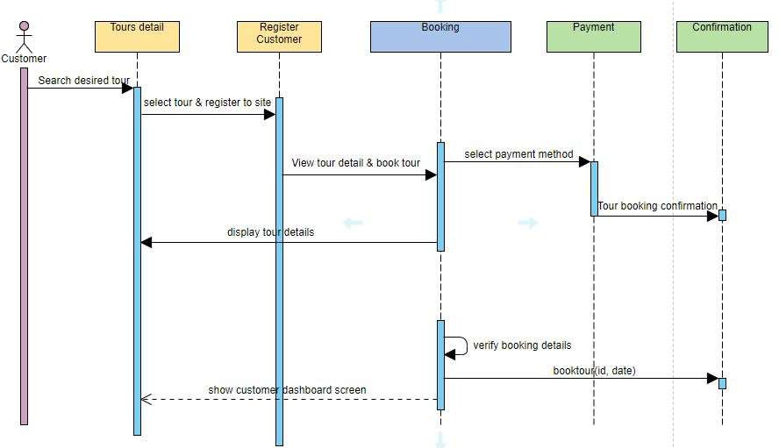

***Figure 4.8:*** Sequence Diagram

### Class diagram

* + - A class diagram in the Unified Modeling Language (UML) is a type of static structure diagram that describes the structure of a system by showing the system's classes, their attributes, operations (or methods), and the relationships among objects.
    - The class diagrams are widely used in the modeling of object oriented systems because they are the only UML diagrams, which can be mapped directly with object-oriented languages. Class diagram shows a collection of classes, interfaces, associations, collaborations, and constraints.
    - Class diagrams are the best way to illustrate a system's structure in a detailed way, showing its attributes, operations as well as its inter-relationships.

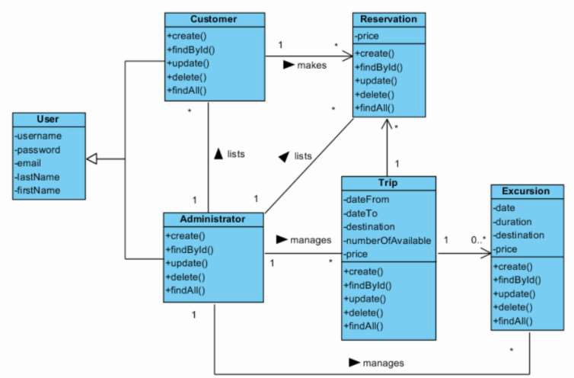

***Figure 4.9:*** Class diagram

### ER Model

* + - **Entity Relationship Model** (ER Modeling) is a graphical approach to database design. It is a high-level data model that defines data elements and their relationship for a specified software system. An ER model is used to represent real-world objects. An Entity is a thing or object in real world that is distinguishable from surrounding environment
    - The three main components of the ER Model are entities, attribute and relationship. In ERM terms, an entity is a "thing" within the organization that we want to keep information about, such as a customer, employee or course.

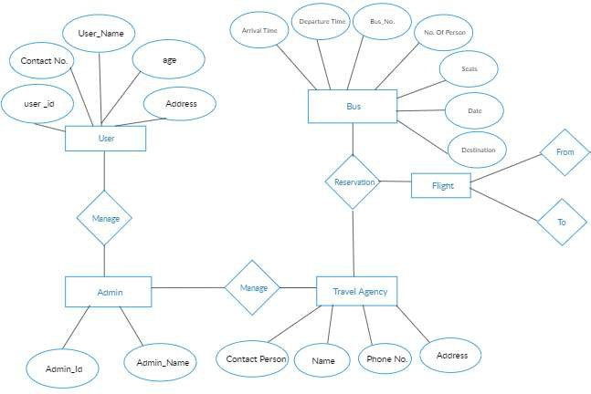

***Figure 4.10:*** ER Diagram

### Data Flow Diagram

* + - Data flow diagrams are used to graphically represent the flow of data in a business information system. DFD describes the processes that are involved in a system to transfer data from the input to the file storage and reports generation. Data flow diagrams can be divided into logical and physical.
    - There are two types of DFD:

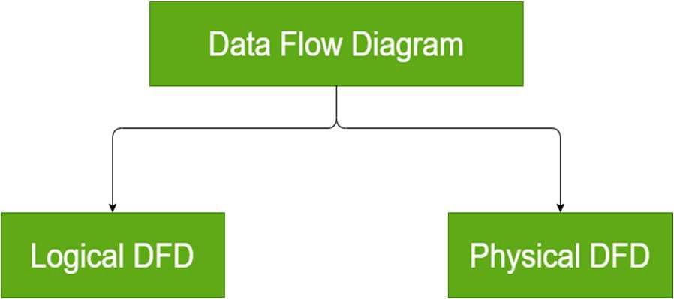

***Figure 4.11:*** Data Flow Diagram

#### Symbols and Notations Used in DFDs

Two common systems of symbols are named after their creators:

* + - * Yourdon and Coad
      * Yourdon and DeMarco
      * Gane and Sarson

#### Data Flow Diagram of Tour Planner

* + - * **Context level DFD**

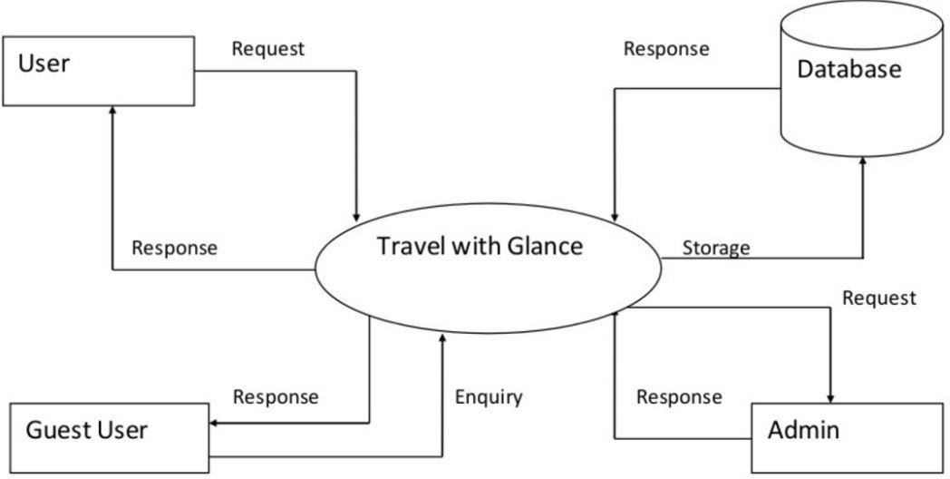

***Figure 4.12:*** Context level DFD

#### Admin level 1 DFD

The Admin side DFD describe the functionality of Admin. Admin is a responsible person who run the project. After login to system admin can first Add Course Detail and Teacher Detail and then add student detail by course wise. Admin can manage student reports and fees payment detail.

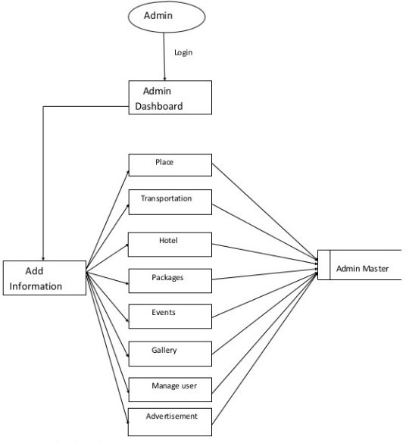

***Figure 4.13:*** Admin level 1 DFD

#### User level 1 DED

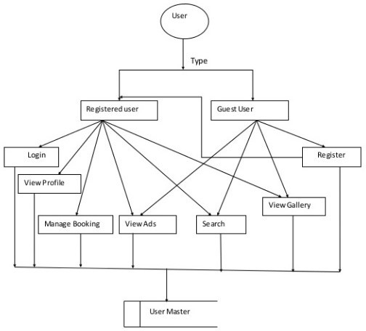

***Figure 4.14:*** User level

#### LEVEL 2 DFD (Tourist Places)

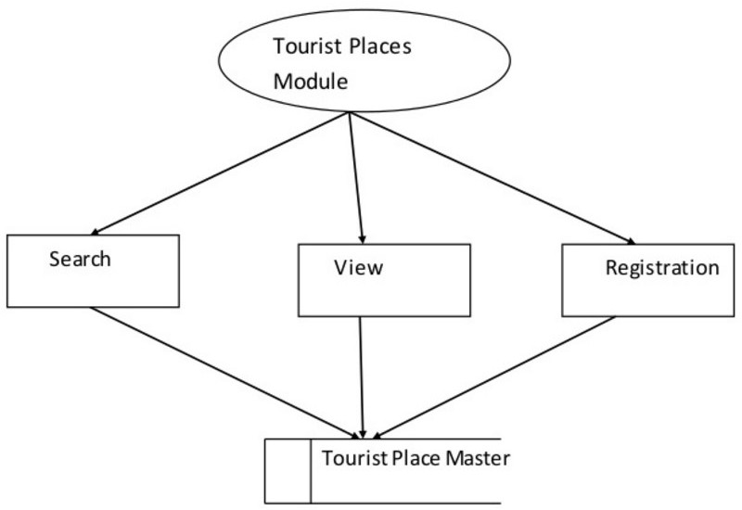

***Figure 4.15:*** Tourist Places

# CHAPTER 5 IMPLEMEMNTATION & TESTING

### Testing Methods

System Testing methods are the various strategies or approaches used to test an application to ensure that it behave and looks as expected. These encompass everything from front to backend testing, including unit and system testing.

### Functional vs non-functional testing

The goal of utilizing numerous testing methodologies in your development process is to make sure your software can successfully operate in multiple environments and across different platforms. These can typically be broken down between functional and non- functional testing. Functional testing involves testing the application against the business requirements. It incorporates all test types designed to guarantee each part of a piece of software behaves as expected by using uses cases provided by the design team or business analyst. These testing methods are usually conducted in order and include:

* + - Unit testing
    - Integration testing
    - System testing
    - Acceptance testing

Non-functional testing methods incorporate all test types focused on the operational aspects of a piece of software. These include:

* + - Performance testing
    - Security testing
    - Usability testing
    - Compatibility testing

The key to releasing high quality software that can be easily adopted by your end users is to build a robust testing framework that implements both functional and non-functional software testing methodologies.

#### Functional Testing

* + - * **Unit Testing**

Unit testing is the first level of testing and is often performed by the developers themselves. It is the process of ensuring individual components of a piece of software at the code level are functional and work as they were designed to. Unit testing can be conducted manually, but automating the process will speed up delivery cycles and expand test coverage. Developers in a test-driven environment will typically write and run the tests prior to the software or feature being passed over to the test team. Unit testing can be conducted manually, but automating the process will speed up delivery cycles and expand test coverage. Unit testing will also make debugging easier because finding issues earlier means they take less time to fix than if they were discovered later in the testing process Test Left is a tool that allows advanced testers and developers to shift left with the fastest test automation tool embedded in any IDE.

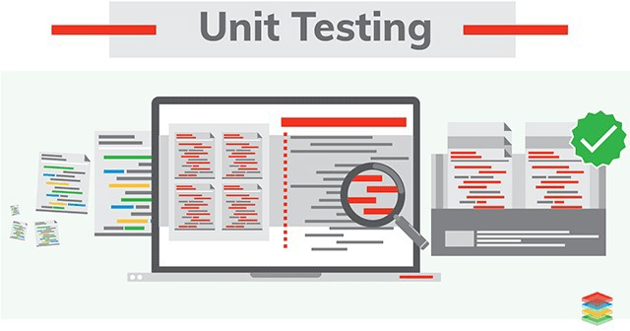

#### Integration Testing

***Figure 5.1:*** Unit Testing

After each unit is thoroughly tested, it is integrated with other units to create modules or components that are designed to perform specific tasks or activities. These are then tested as group through integration testing to ensure whole segments of an application behave as expected (the interactions between units are seamless). These tests are often framed by user

scenarios, such as logging into an application or opening files. Integrated tests can be conducted by either developers or independent testers and are usually comprised of a combination of automated functional and manual tests.



#### System Testing

***Figure 5.2:*** Integration Testing

System testing is a black box testing method used to evaluate the completed and integrated system, as a whole, to ensure it meets specified requirements. The functionality of the software is tested from end-to-end and is typically conducted by a separate testing team than the development team before the product is pushed into production.

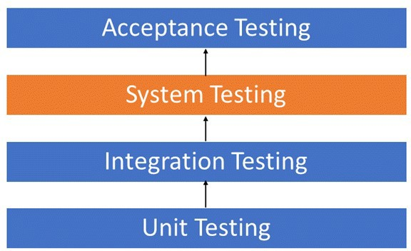

***Figure 5.3*** System Testing

#### Acceptance Testing

Acceptance testing is the last phase of functional testing and is used to assess whether or final piece of software is ready for delivery. This requires the product be tested both internally and externally, meaning you’ll need to get it into the hands of your end users for beta testing along with those of your QA team. **Acceptance tests** are carried out upon reception of new devices or equipment. The **purpose of acceptance testing** is to verify that the correct devices have been delivered according to the contract conditions and technical specifications, and in some cases, whether the equipment is properly installed. This requires the product be tested both internally and externally, meaning you’ll need to get it into the hands of your end users for beta testing along with those of your QA team.

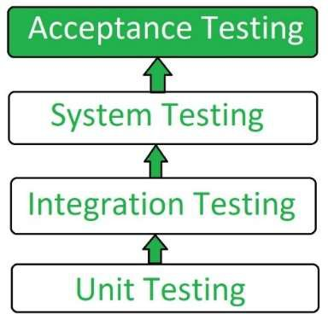

***Figure 5.4:*** Acceptance Testing

#### Non- functional Testing

Performance testing is a non-functional testing technique used to determine how an application will behave under various conditions. The goal is to test its responsiveness and stability in real user situations. It is designed to test the readiness of a system as per non- functional parameters which are never addressed by functional testing. An excellent example of non-functional test would be to check how many people can simultaneously login into a software. The goal is to test its responsiveness and stability in real user situations. Performance testing can be broken down into four types:

#### Load testing

Load testing is the process of putting increasing amounts of simulated demand on your software, application, or website to verify whether or not it can handle what it’s designed to handle. When the load is increased beyond normal usage patterns, in order to **test** the system's performance at exceptionally high or peak loads, it is known as stress testing. Load testing is performed to find out the upper limit of the system or application.

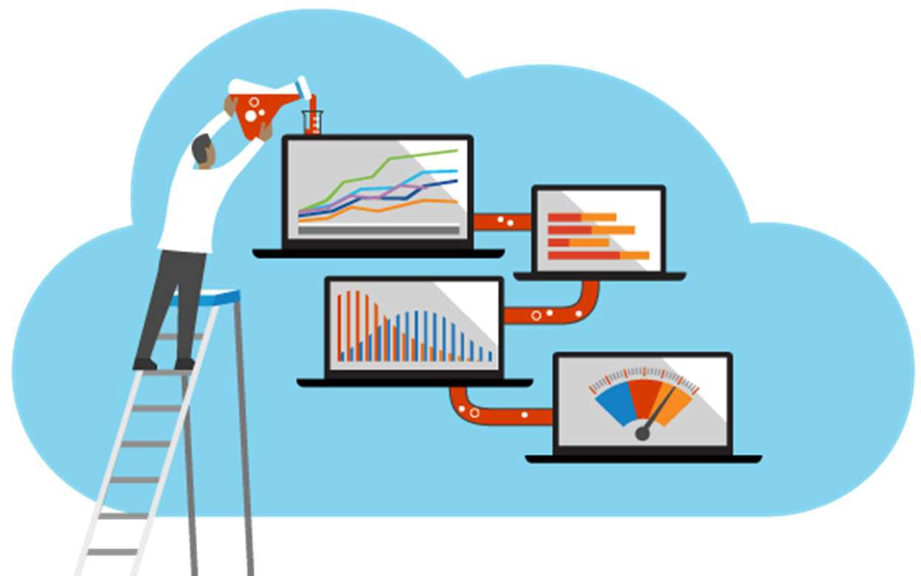

***Figure 5.5:*** Load Testing

#### Stress testing

Stress testing takes this a step further and is used to gauge how your software will respond at or beyond its peak load. The goal of stress testing is to overload the application on purpose until it breaks by applying both realistic and unrealistic load scenarios. With stress testing, you’ll be able to find the failure point of your piece of software. **Stress testing** refers to a type of **testing** that is so harsh, it is expected to push the program to failure.

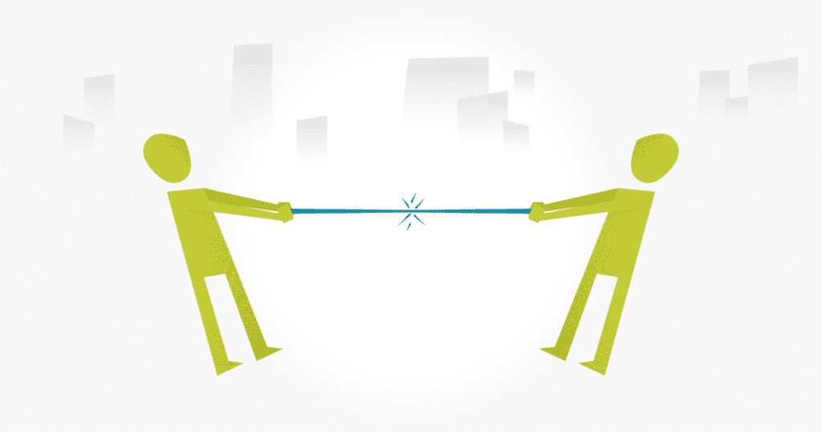

***Figure 5.6:*** Stress Testing

#### Endurance testing

Endurance testing**,** also known as soak testing, is used to analyze the behavior of an application under a specific amount of simulated load over longer amounts of time. The goal is to understand how your system will behave under sustained use, making it a longer process than load or stress testing (which are designed to end after a few hours). A critical piece of endurance testing is that it helps uncover memory leaks.

#### Spike testing

Spike testing is a type of load test used to determine how your software will respond to substantially larger bursts of concurrent user or system activity over varying amounts of time. The goal is to purposefully find loopholes and security risks in the system that could result in unauthorized access to or the loss of information by probing the application for weaknesses. There are multiple types of this testing method, each of which aimed at verifying six basic principles of security:

* + - * + Integrity
        + Confidentiality
        + Authentication
        + Authorization
        + Availability
        + Non-repudiation

#### Usability testing

Usability testing is a testing method that measures an application’s ease-of-use from the end-user perspective and is often performed during the system or acceptance testing stages. The goal is to determine whether or not the visible design and aesthetics of an application meet the intended workflow for various processes, such as logging into an application.

#### Compatibility testing

Compatibility testing is used to gauge how an application or piece of software will work in different environments. It is used to check that your product is compatible with multiple operating systems, platforms, browsers, or resolution configurations. The goal is to ensure that your software’s functionality is consistently supported across any environment you expect your end users to be using.

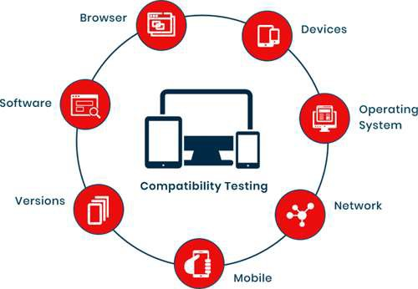

***Figure 5.7:*** Compatibility Testing

### Test Cases

A test case is the set of steps that need to be done in order to test a specific function of the software. They are developed for various scenarios so that testers can determine whether the software is working the way it should and producing the expected results.

#### Data and Database Integrity Testing

***Table 5.1:*** Data Integrity Testing

|  |  |  |
| --- | --- | --- |
| **Test Objectives** | Our main objective of this is to ensure that the tables we created rightly Objective accessed from the user interfaces and rightly updated, modified and deleted data from the tables | |
| **Test Cases** | **Test Case Description** | **Result** |
| Provide login information | Data entered Successfully |
| Select a specific task and complete it | Task has been completed |
| Add all queries related to booking, payment method, cancellation and confirmation of tour | All data has successfully entered |
| **Completion criteria** | All tables that created are successfully accessed from the user interfaces and successfully updated, modified and deleted. | |
| **Special** | MYSQL server is uses as DBMS | |

#### Function testing

***Table 5.2:*** Function Testing

|  |  |  |
| --- | --- | --- |
| **Test Objectives** | Our main objective of this is to test functions that are on a services provider/user/admin interface that fulfilling their functionality data entry, and retrieval. | |
| **Test Cases** | **Test Case Description** | **Result** |
| Check all buttons that helps user to navigate from one their functions. Page to another. | All the buttons successfully performed their functions. |
| Check login | Valid person successfully logged in. |
| All data entry opertions can be checked by entering data. | All data entry opertaions successfully performed their functionalities. |
| Check anyother function. | All other functions performed their functionalities. |
| Completion | All functions successfully performed their functionalities. | |

#### User interface Testing

***Table 5.3:*** User Interface Testing

|  |  |  |
| --- | --- | --- |
| **Test Objective** | Our main objective of this to do check navigation including window to window,field to field,and use of access methods e.g focus on other characteristics like size,position, state,colors and any other characteristics | |
| **Test Cases** | **Test Case Description** | **Result** |
| Every service provider like admin and user.  Interface can be checked one by one. | All characteristics that are mentioned above are fulfill |
| **Completion Criteria** | Tab key, esc key work properly. Mouse movement is ok. Colors are professional and text colour is ok.  Text is easily readable and navigation among pages is ok. | |
| **Special Consideration** | Attractive interface | |

#### Performance Testing

***Table 5.4:*** Performance Testing

|  |  |  |
| --- | --- | --- |
| **Test Objectives** | Main goal of this is that when admin add, modify and delete data and place a new data the response showed in a proper time or not.  What happened when a lot of data entered at the same time to server? | |
| **Test Cases** | **Test case Description** | **Result** |
| When a lot number of request come from Application. | This application has its own server so all these requests should be fulfilled in proper time. |
| When admin enter, delete or modify any entity. | Database server respond quickly |
| **Criteria** | There is no restriction for data. Data can be eassily modified | |
| **Special** | The database server should have capability to respond at proper time duration. | |

#### Security and access control testing

***Table 5.5:*** Security and access testing

|  |  |  |
| --- | --- | --- |
| **Test Objectives** | Our main objective of this is to check’s system security and access control testing | |
| **Test Cases** | **Test Case Description** | **Result** |
| Errors during viewing data by admin. | No need to worry .Nothing happened. |
| **Completion Criteria** | Nothing special consideration for this except administrator. | |
| **Special Consideration** | Nothing | |

# CHAPTER 6 USER MANUAL

### Main/Home view

* + - A home page is the main web page of a website.The term also refers to one or more pages always shown in a web browser.When the application starts up.In this it is also known as start page.

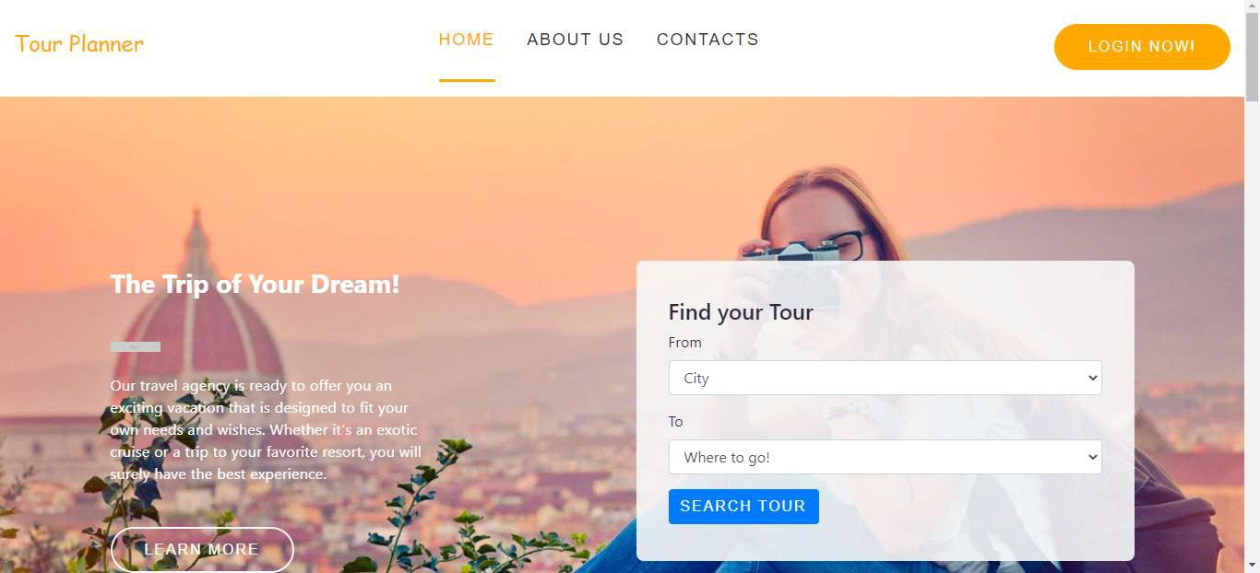

***Figure 6.1:*** Home Screen

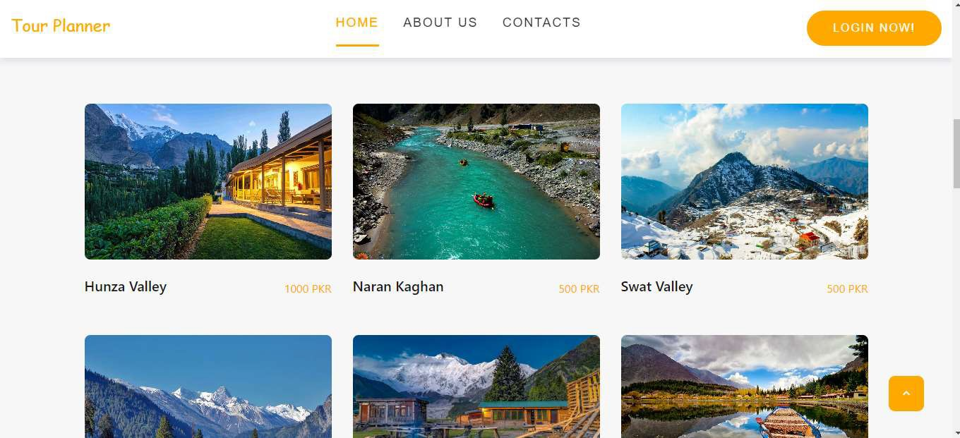

***Figure 6.2:*** Home Page Tours Detail

* + - In this section services are shown:

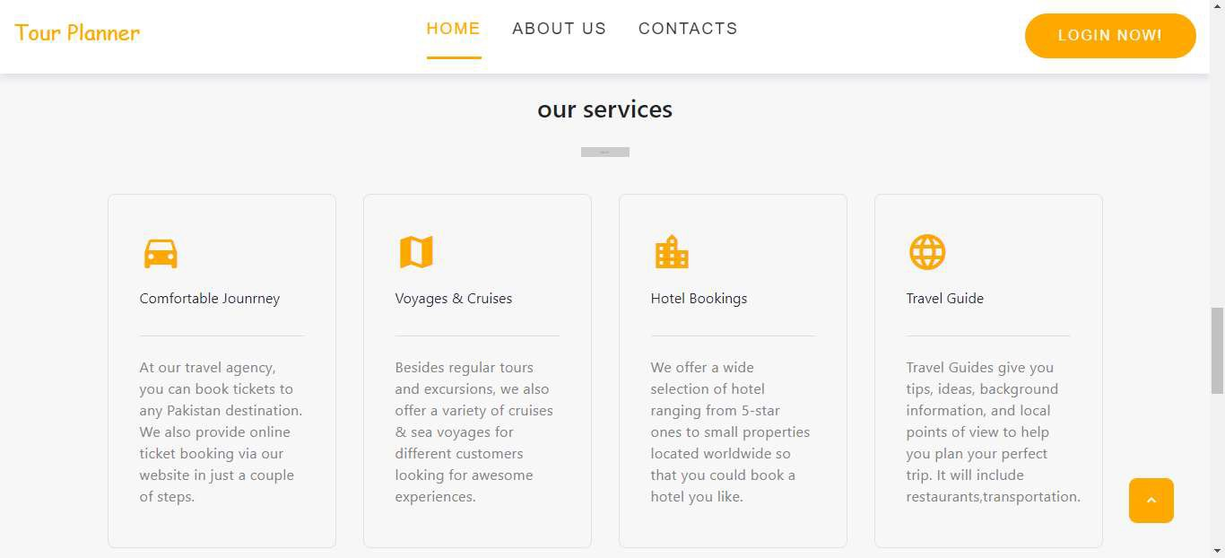

***Figure 6.3:*** Home page Services

* + - Here Admin can add customer experience regarding tour:

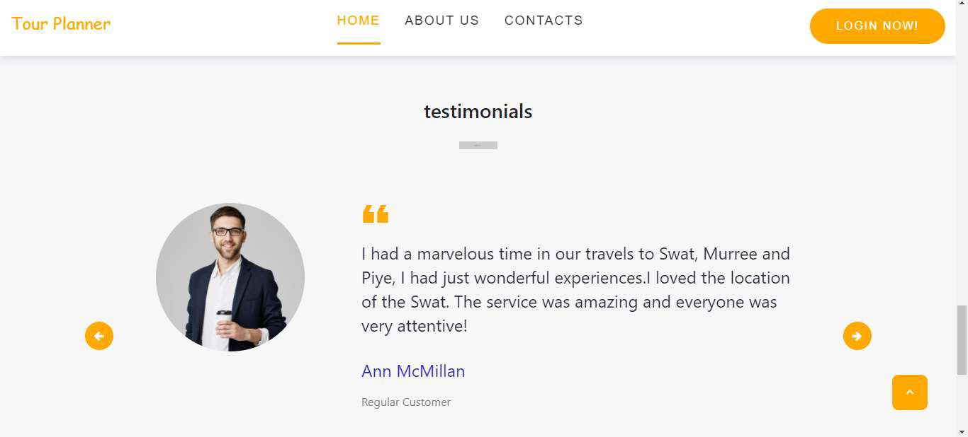

***Figure 6.4:*** Testimonial

### About Agency

* + - This page may give the information about tour agency their services and some places information.It describe the agency timeline too**.**

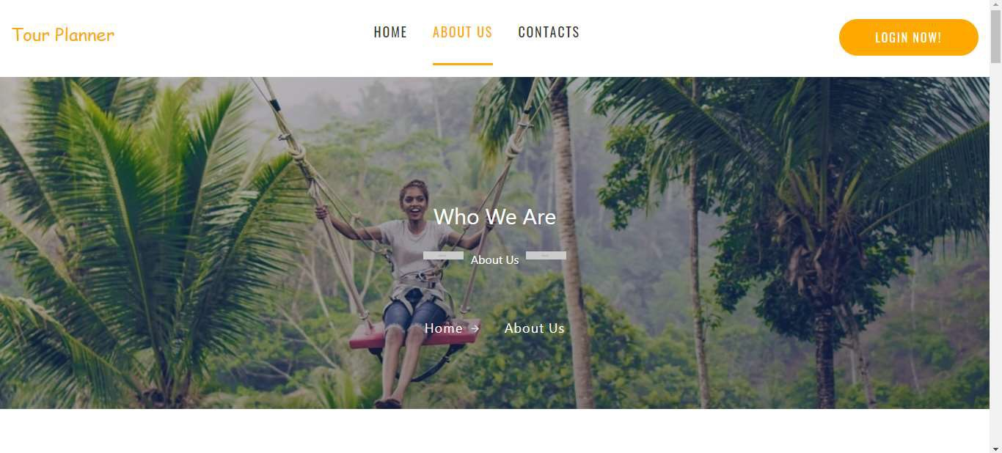

***Figure 6.5:*** About page

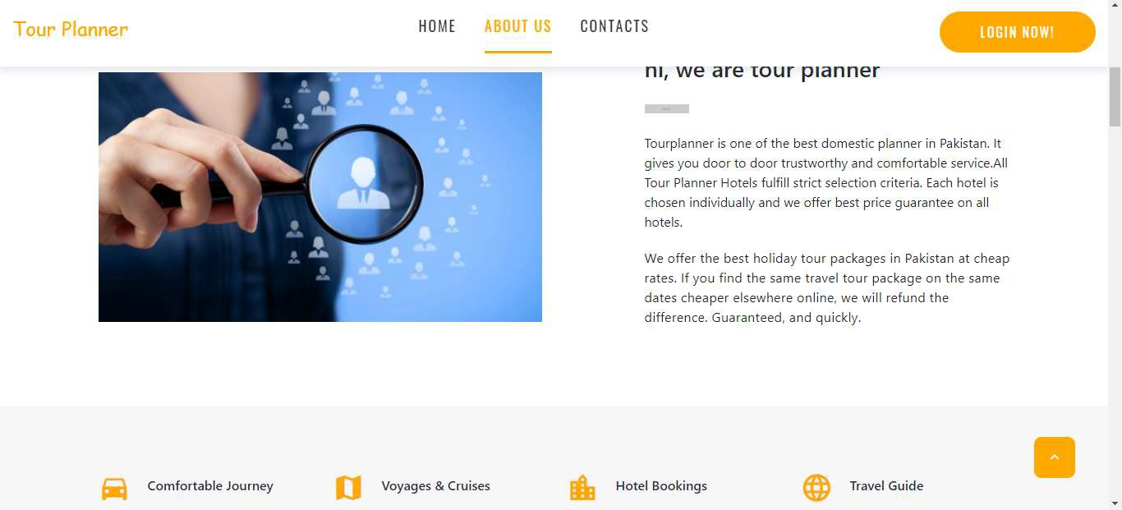

***Figure 6.6:*** About Agency

* + - Team details of tour planner:

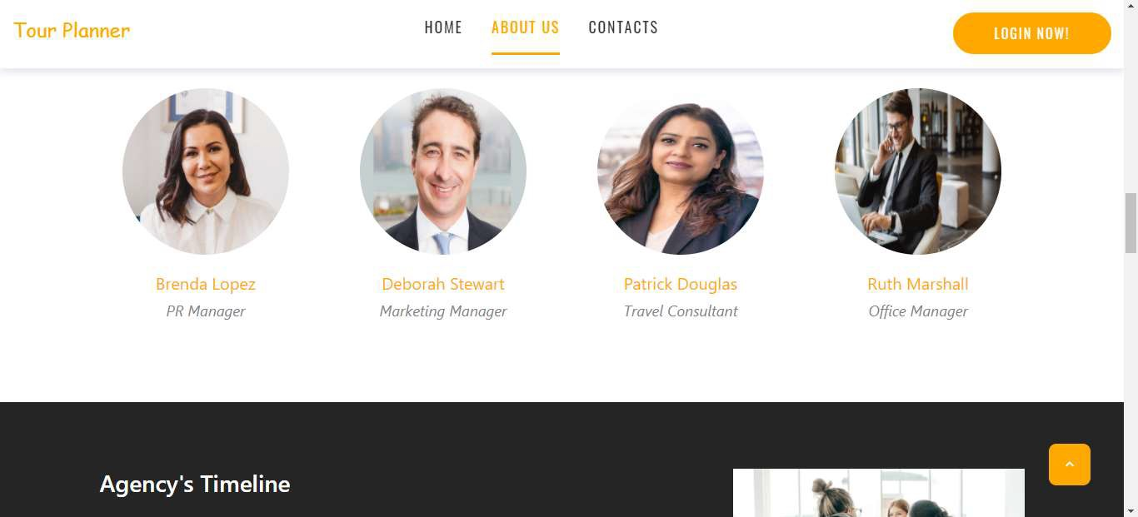

***Figure 6.7:*** Team

* + - Agency Timeline:

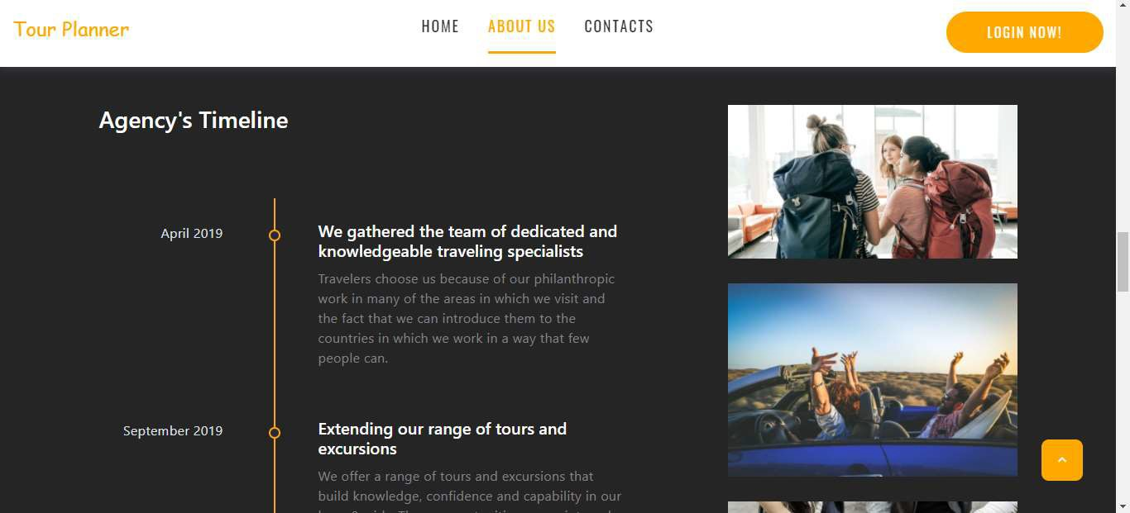

***Figure 6.8:*** Agency Timeline

* + - Destinations Detail:

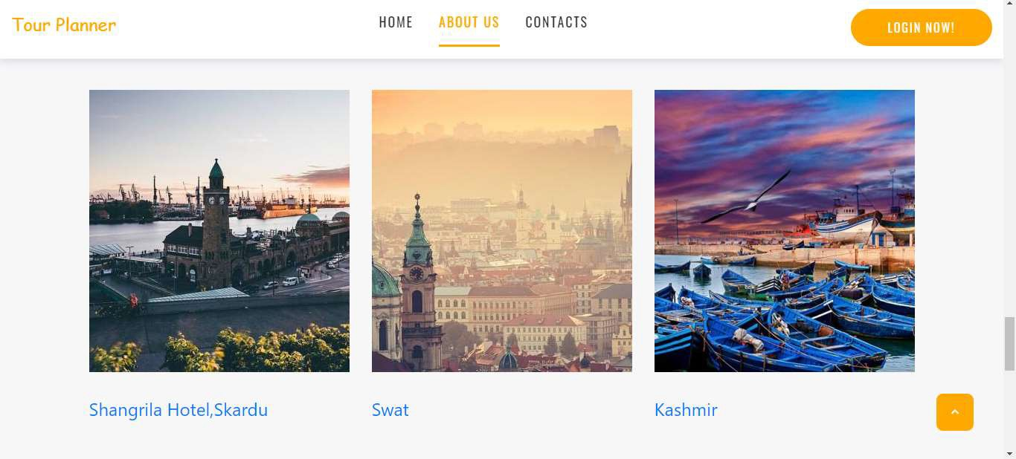

***Figure 6.9:*** Destinations

### Contact page

* + - This contact us page is for public queries and for contact with Admin**.**

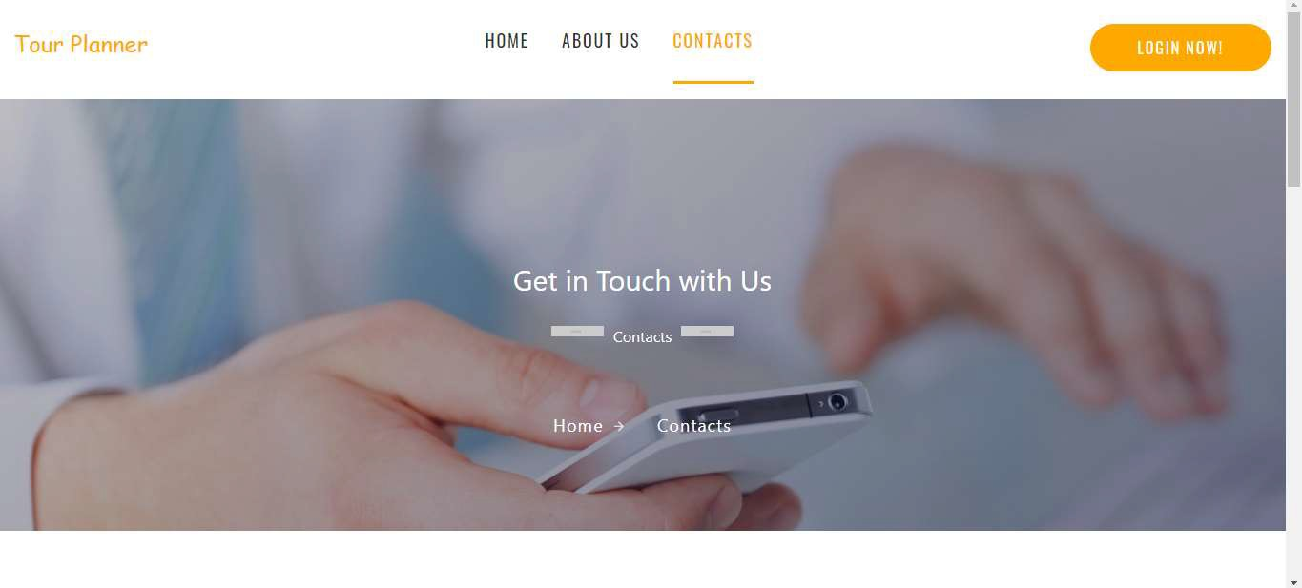

***Figure 6.10:*** Contact Us

* + - Contact Form:

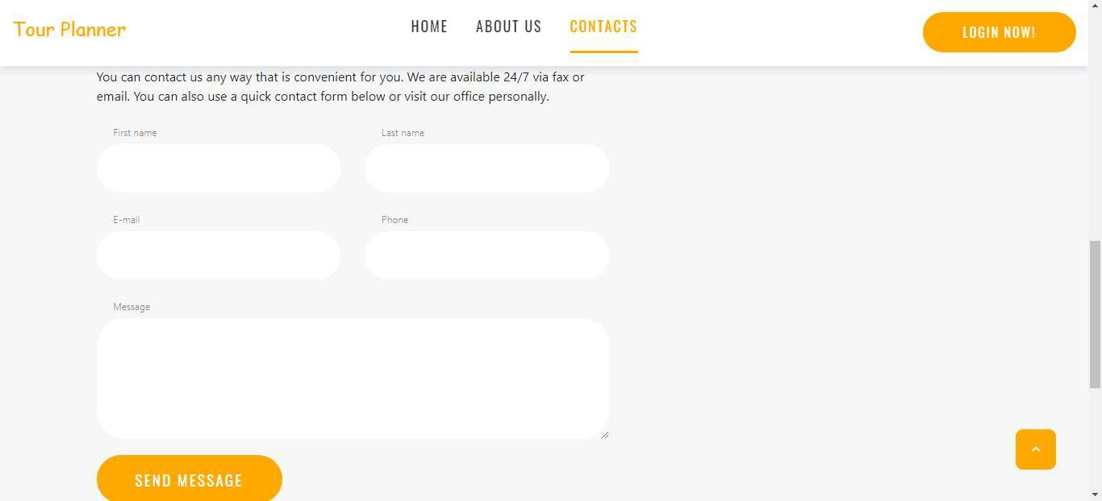

***Figure 6.11:*** Contact Form

* + - Footer Detail:

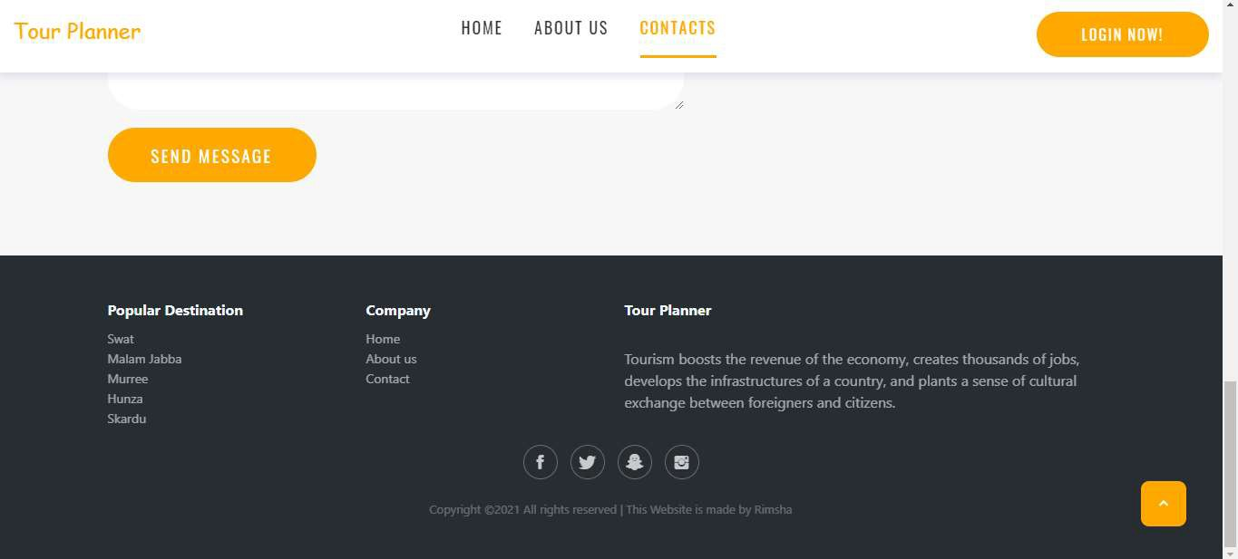

***Figure 6.12:*** Footer

### Tour detail page

* + - This page contain all the information about tour. Arrival date, departure date, Tour name, Destination, Price, Food plan and Conveyance.

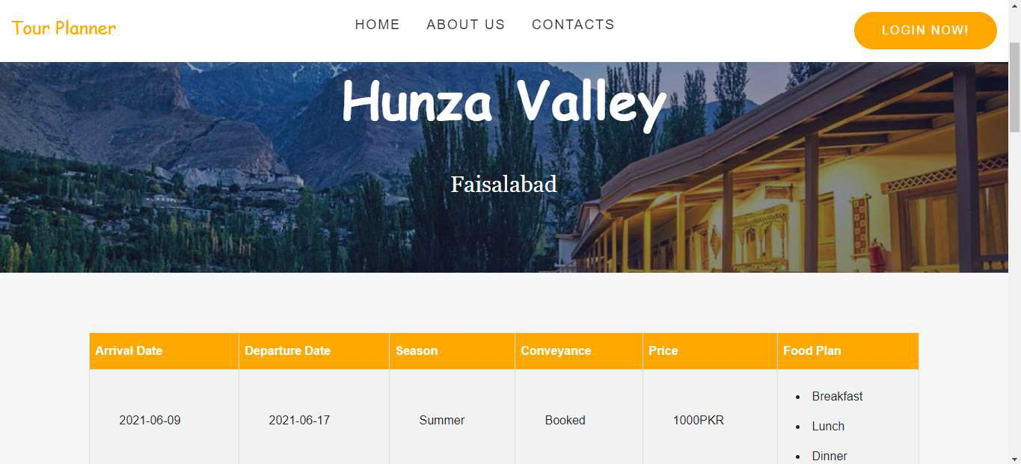

***Figure 6.13:*** Tour detail

### Signup/Login page

* + - Through Signup form customer can register his/herself. Then after register customer can easily booked a tour after login.

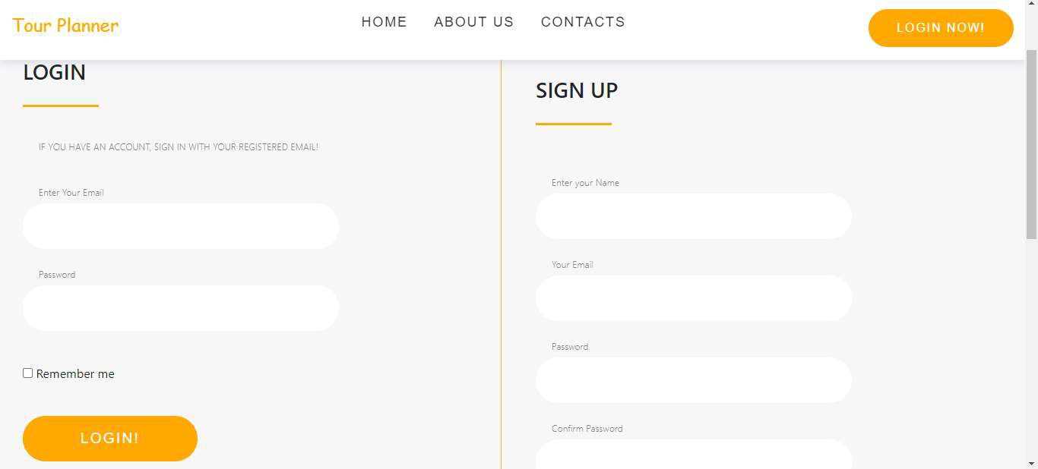

***Figure 6.14:*** Signup and login form

### Tour booking form

* + - In this form customer add full booing detail for booked a tour. Firstly enter his/her First name, Last name, Email, Contact number, Location, Destination, Pickup time, No. of adults, No. of children and Destination detail then click to booked button for booking.

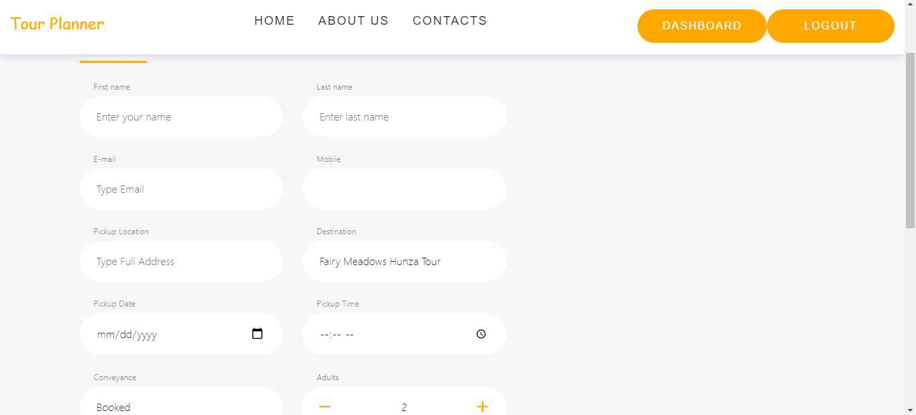

***Figure 6.15:*** Booking form

### Payment Method

* + - After booked a tour customer move on payment method. Here customer enter Owner name, Credit card no, Expiry Date, Expiry month and Card code.

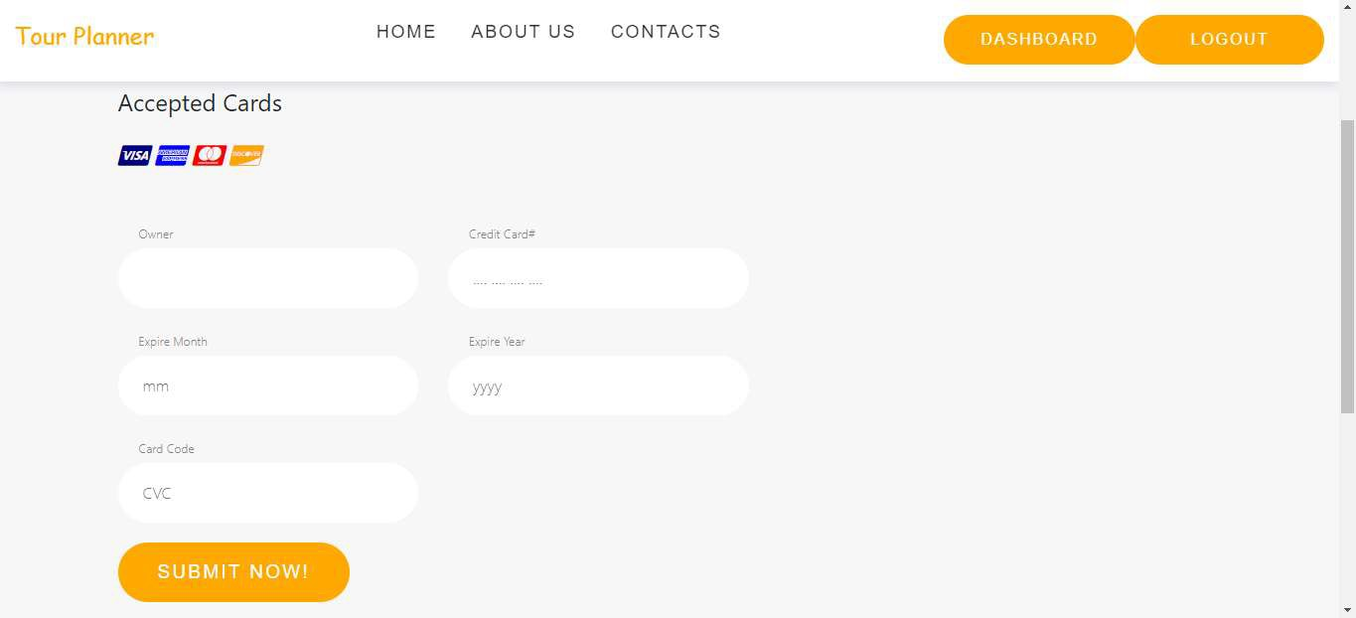

***Figure 6.16:*** Payment method

### Successfully Booked

* + - After booking and payment method customer receive confirmation message.

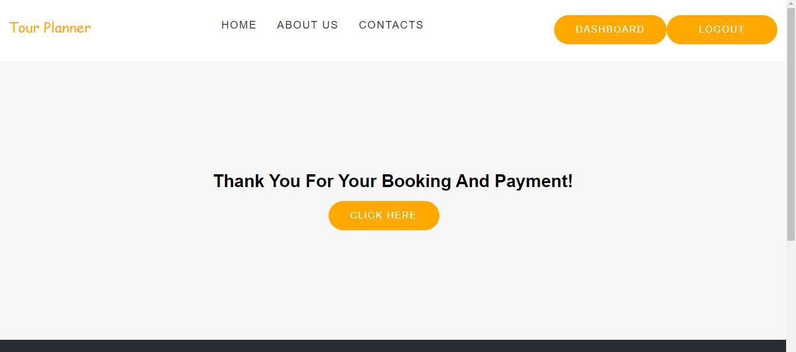

***Figure 6.17:*** Booked Successfully

### User Dashboard

* + - In user dashboard user can view his/her booked tour and can also update booking.

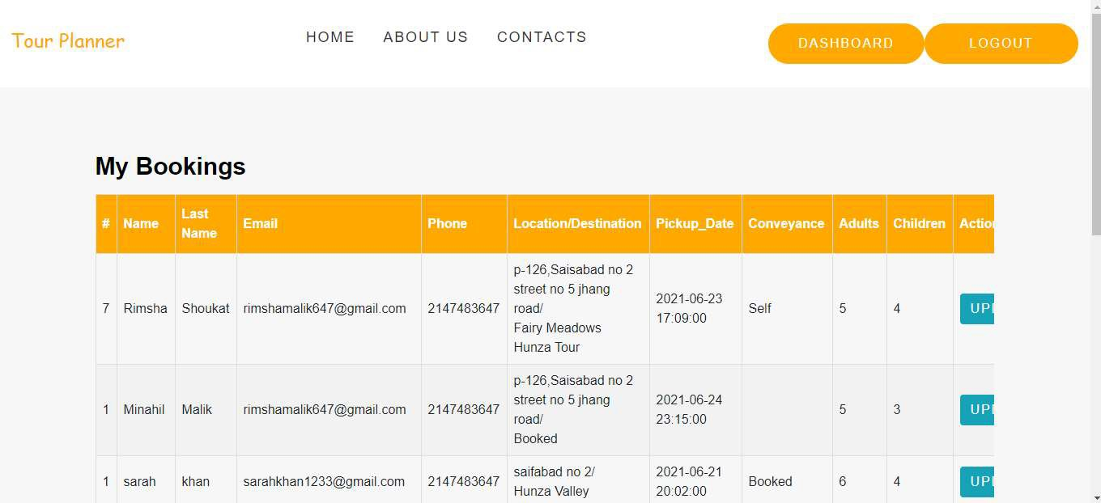

***Figure 6.18:*** User dashboard

### Admin Dashboard

* + - Through Dashboard admin can add, delete and update slider images, Admin can also add, delete and update tour and places. And also manage testimonial, booking details and customer messages.

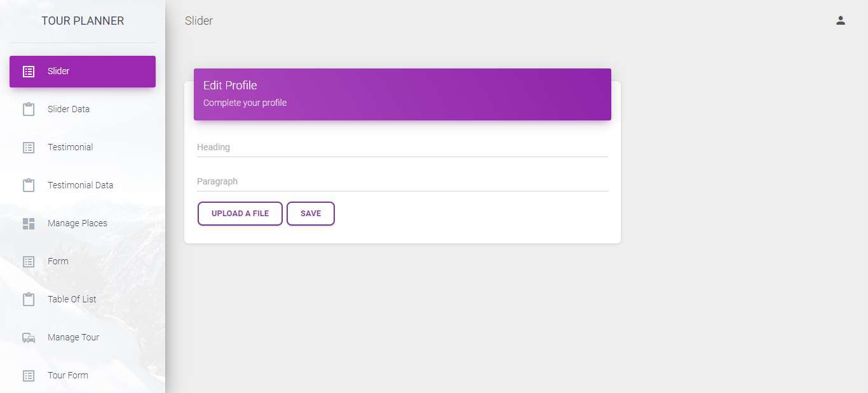

***Figure 6.19:*** Admin Dashboard

### Testimonial

* + - Through this admin can manage testimonial images and comments of customer.

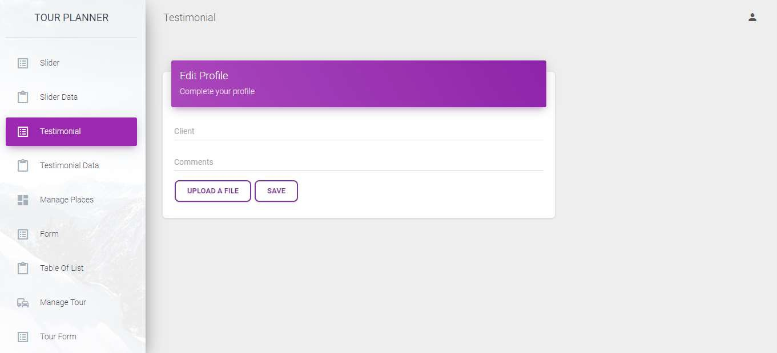

***Figure 6.20:*** Testimonial

### Manage Tour

* + - Through this admin can manage tour detail.

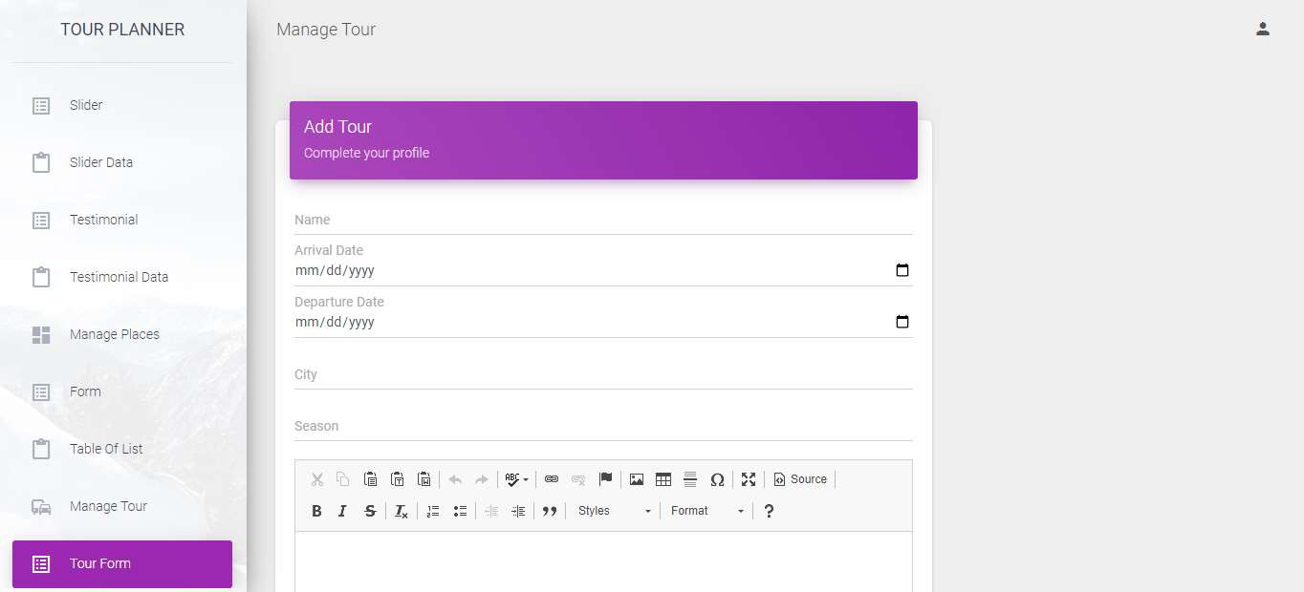

***Figure 6.21:*** Manage Tour

### Manage Bookings

* + - Through booking panel admin can manage booking, confirm and cancel the tours.

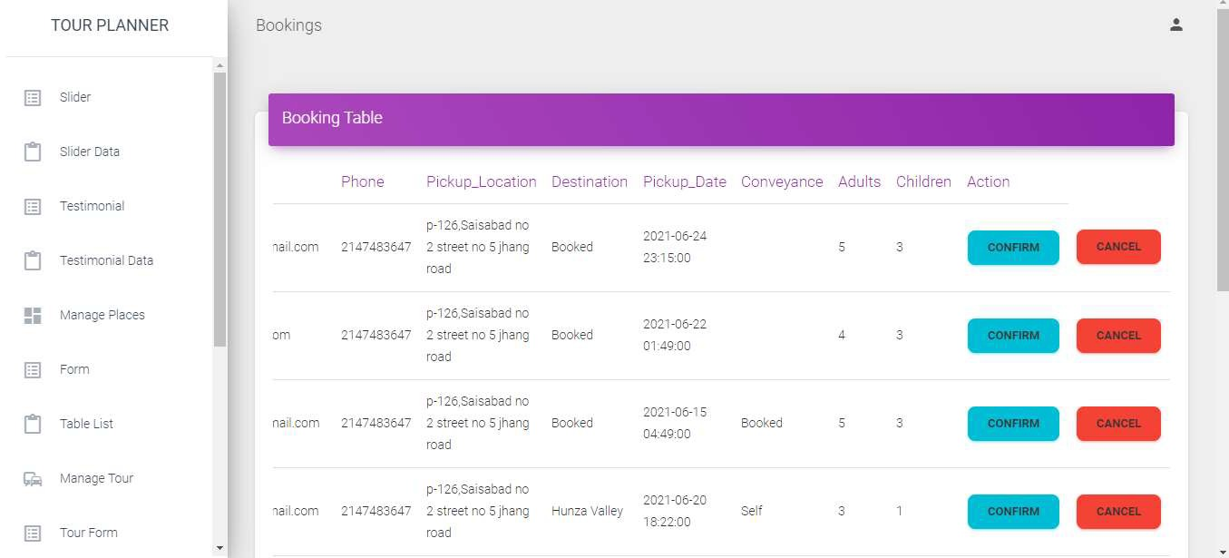

***Figure 6.22:*** Manage Booking

### Read Messages

* + - Admin can read message and give response to the customer.

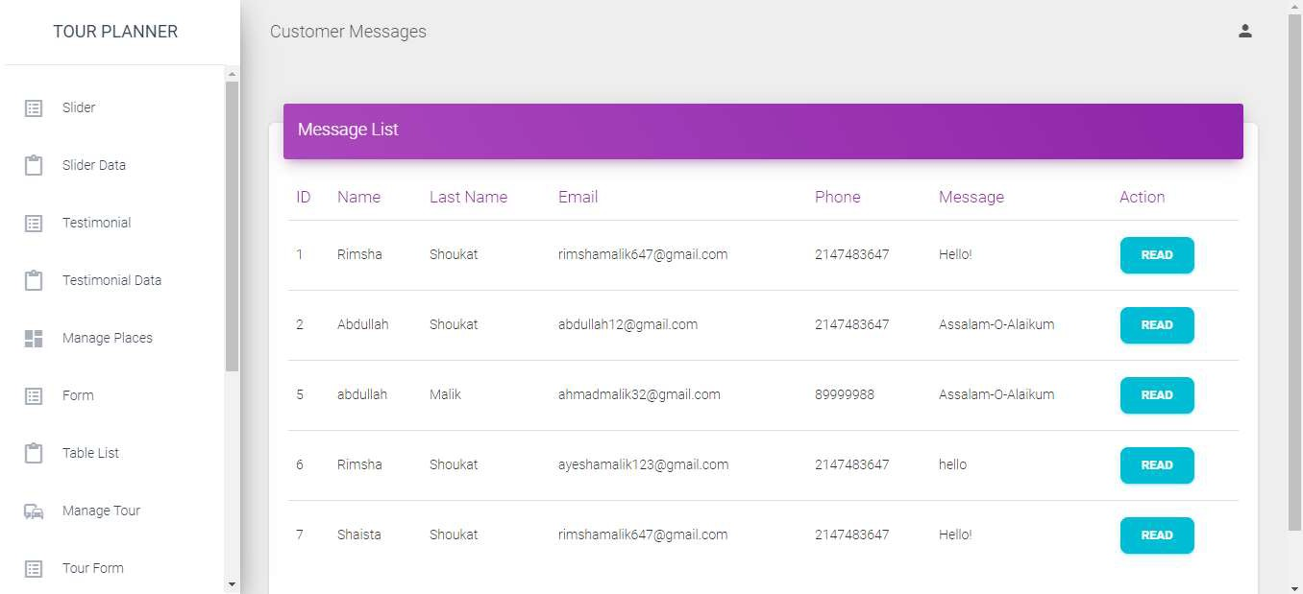

***Figure 6.23:*** Read Messages

### Coding

* + - A programming (or coding) language is a set of syntax rules that define how code should be written and formatted. Thousands of different programming languages make it possible for us to create computer software, apps and websites.

#### Database Connection File

* + - * This file is used for connection with database.

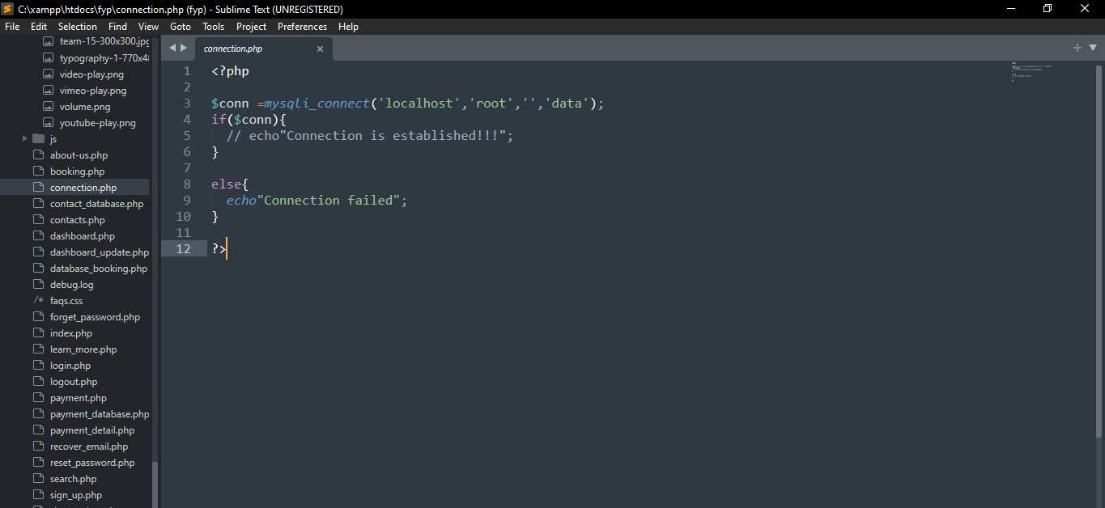

***Figure 6.24:*** Connection

#### Admin Panel code

* + - * Admin panel code through where admin can manage everything.

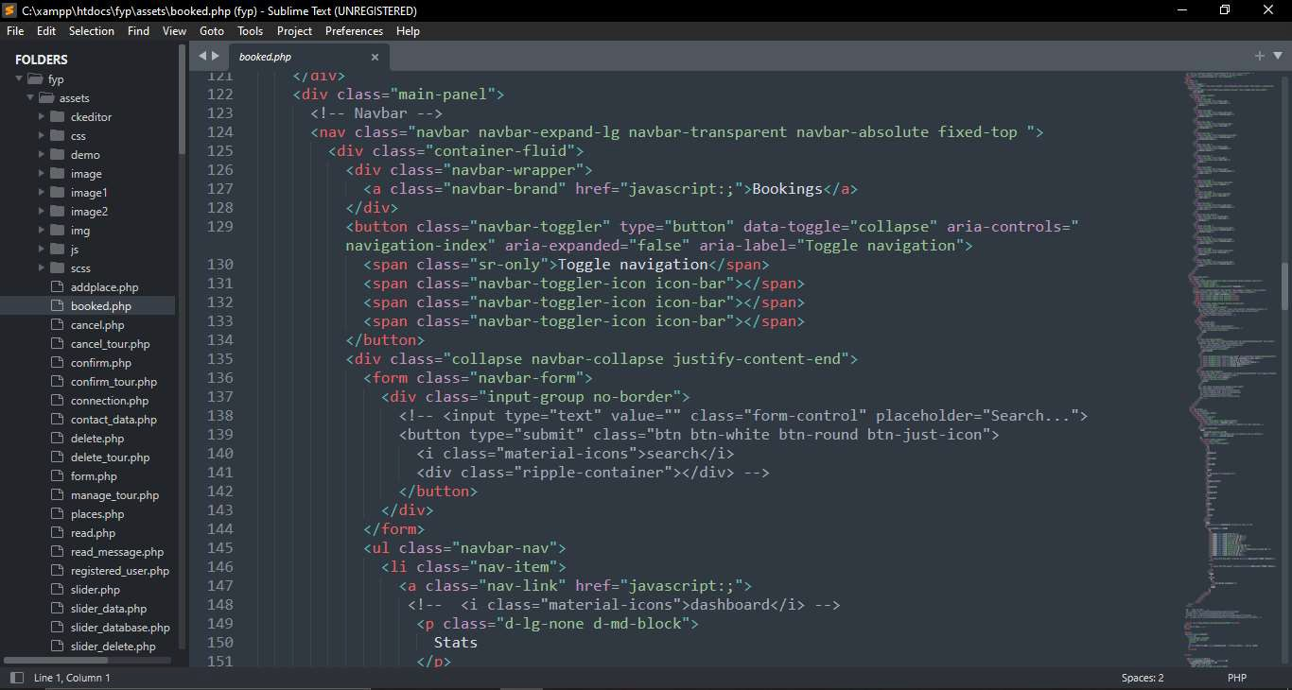

***Figure 6.25:*** Admin Panel

#### Frontend Code

* + - * The **frontend** of a software program or website is everything with which the user interacts.

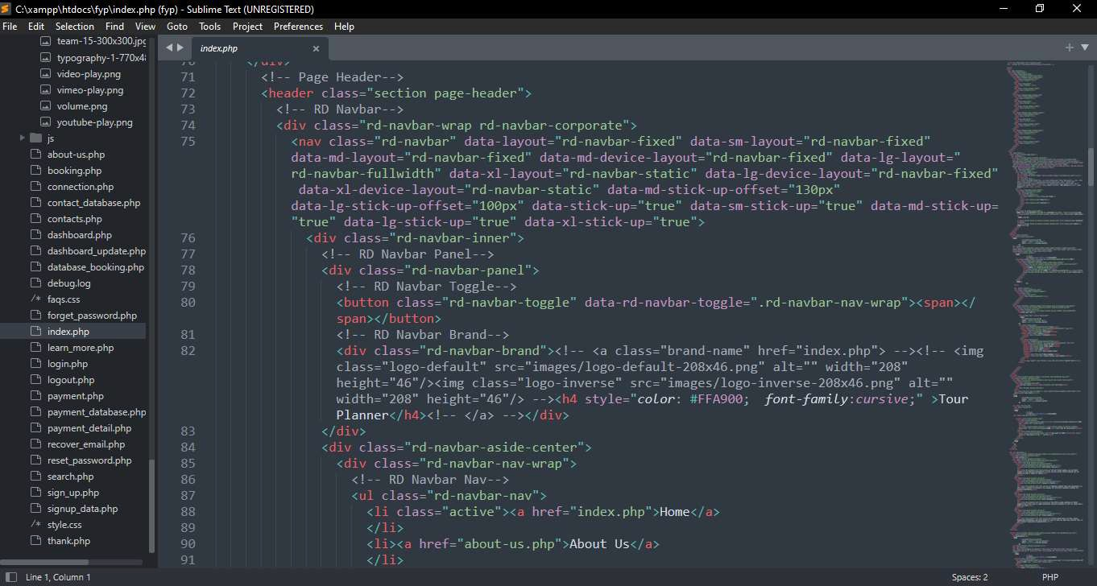

***Figure 6.26:*** Frontend

### Database

* + - In computing, a database is an organized collection of data stored and accessed electronically from a computer system. Where databases are more complex they are often developed using formal design and modeling techniques.

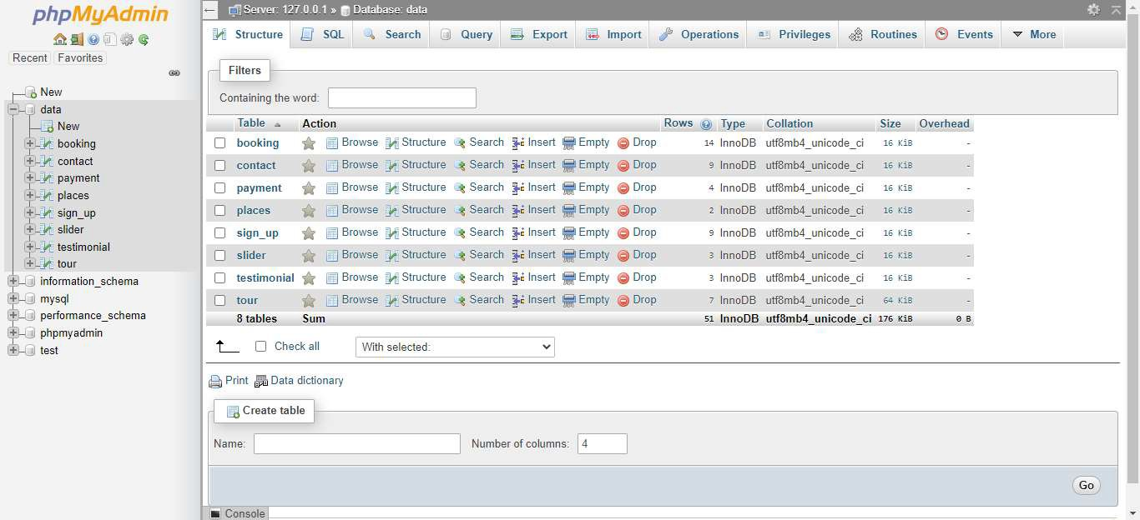

***Figure 6.27*:** Database

### Tour Record

* + - Here is the all record of tour.

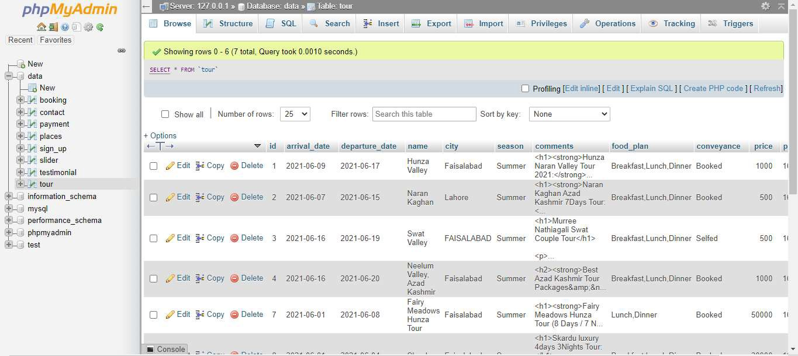

***Figure 6.28:*** Tour Record

### Booking Record

* + - Booking record of customers.

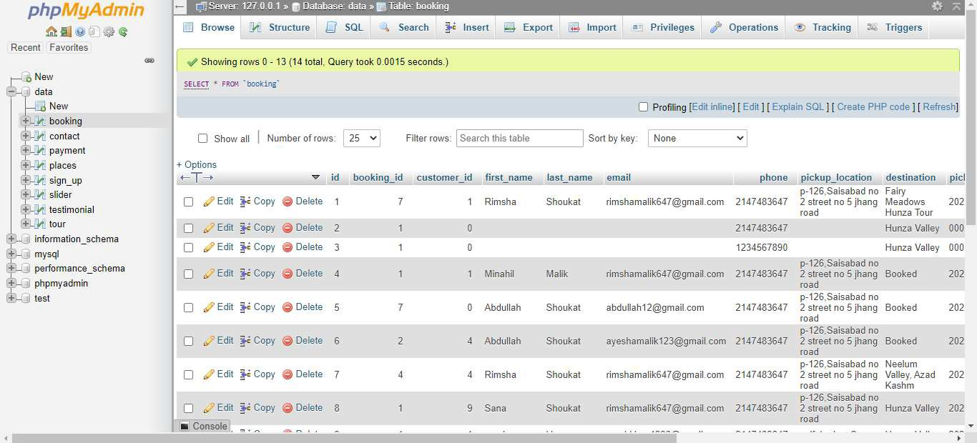

***Figure 6.29:*** Booking record

### Contact detail

Detail of customers who contact with admin.

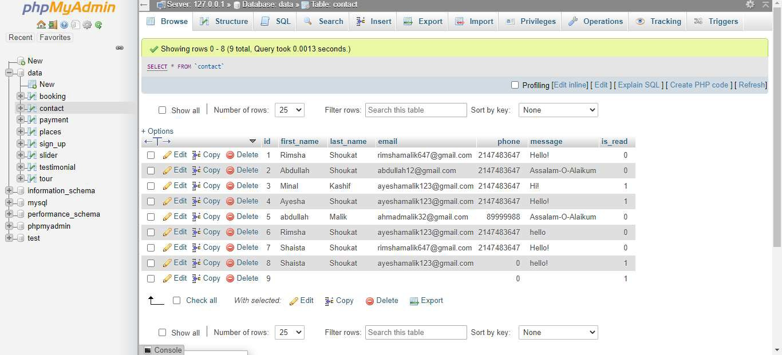

***Figure 6.30:*** Contact detail

### Payment detail

* + - When customer enter payment detail then it show in database.

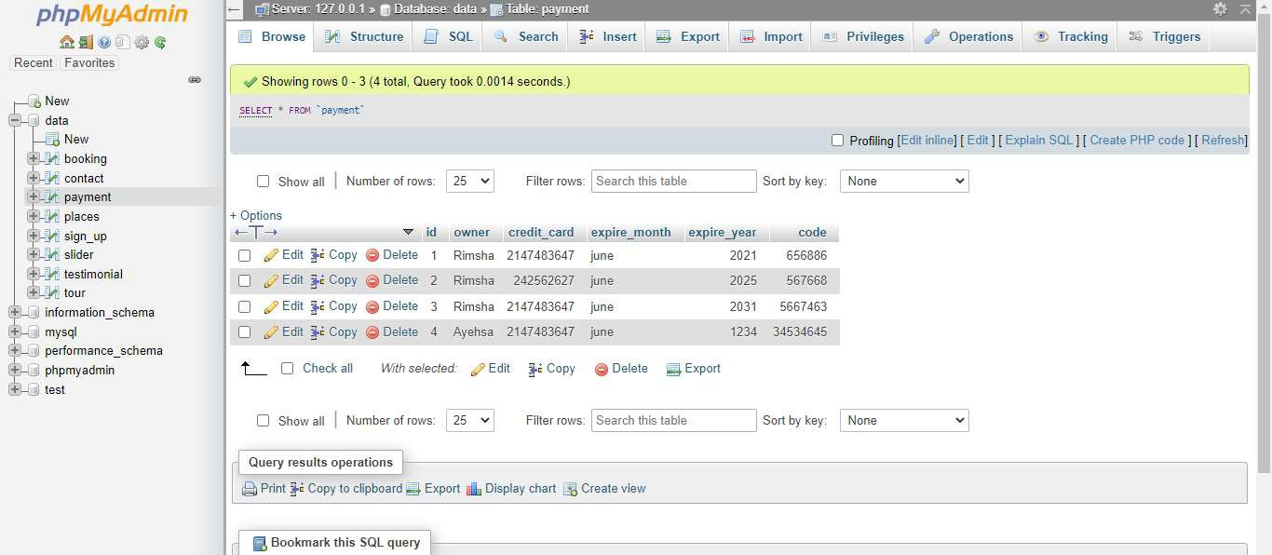

***Figure 6.31:*** Payment detail

### Slider detail

* + - Here is a detail about slider text and images.

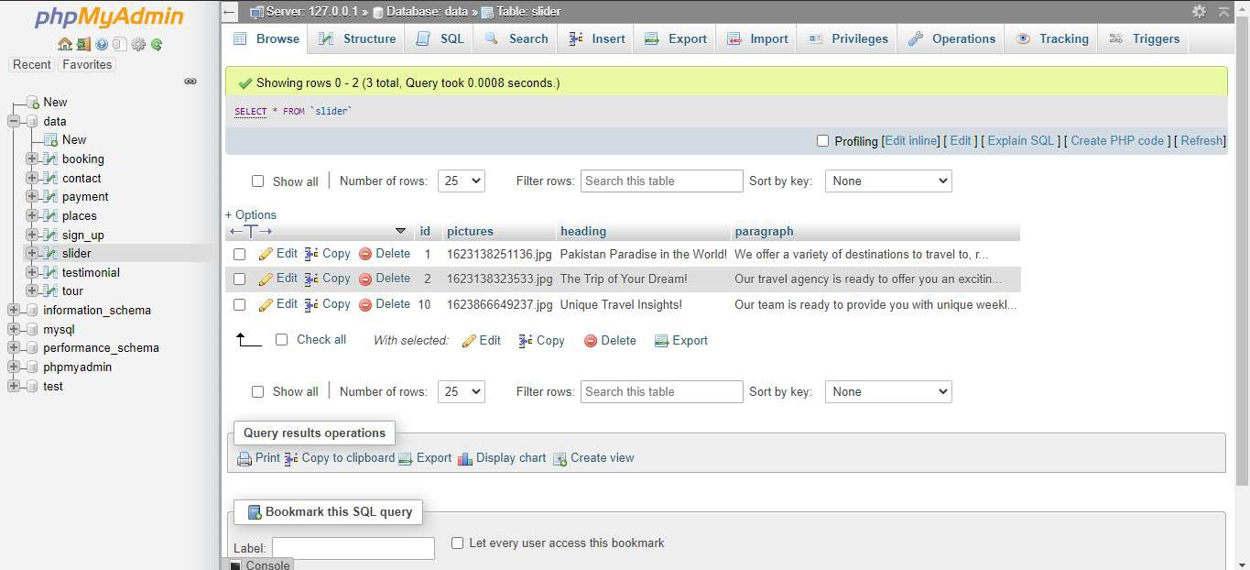

***Figure 6.32:*** Slider detail

### Testimonial detail

* + - Here the detail about customer’s experience and then admin can add these details on website.

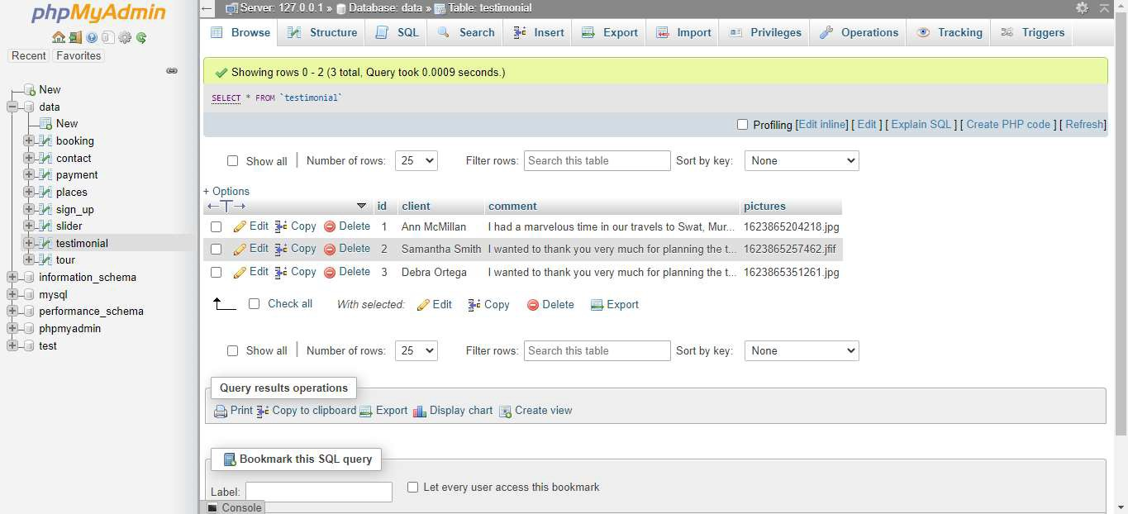

***Figure 6.33:*** Testimonial details

### Places detail

* + - Admin can add popular destination detail.

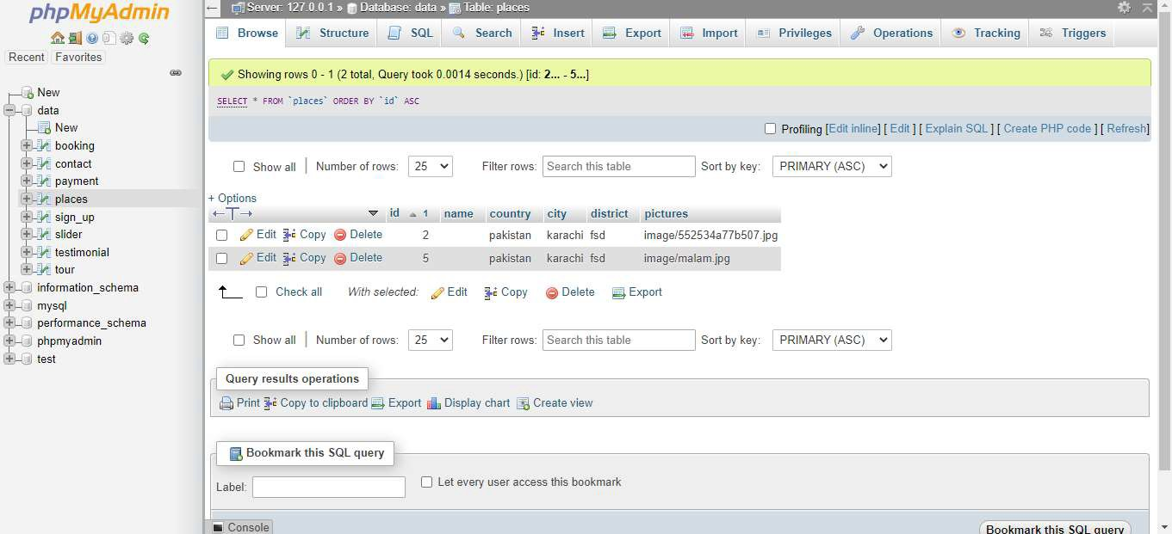

***Figure 6.34:*** Places detail